**ACKNOWLEDGEMENT**

Sixth semester project is a minor component of academics schedule of B.C.A. Hence I worked on **AQUA CONTROL**. I would like to express my special thanks to gratitude my computer teacher “Mr. Pankaj Mishra” for his able guidance and support in completing this project.

I express my whole hearted gratitude towards- **College of Innovative Management and Science** for giving me the opportunity to undergo my project in the field of website development of great report and allowing me gain invaluable experience. I express my heart – felt gratitude to “Prof. Dr. Manish Kumar” for guiding me during the project period. I also express my special thanks to all the staff who has gave me their precious time and help me whenever required. I am thankful to my parent who has always been supportive in my correct decision and giving me useful advice. I also express my sincere thank to all respondent without whose help completion of this project is not possible.

**PREFACE**

I am glad to make this project CINE TICKET PRO and now I make this project report. In this project report, I include about my project, objective of project, lists of project activities .

Doing this project I have a great experience and I get knowledge about boutique system. These all experience and knowledge I am going to share by my project report.

During work on this project I met many technical problems. These technical problems are solved by our Teacher Prof. Dr. Manish Kumar. He is very helpful for me in this project so I am very thankful to him.

Thanking you.

**DECLARATION**

I declare that final semester report entitled “AQUA CONTROL” is my own work conducted under the supervision of the external guide Mr. Pankaj Mishra.

I further declare that to the best of my knowledge the report for B.C.A final semester does not contain part of the work has been submitted for the award of B.C.A Degree either in this or any other university without proper citation.

Also I declare that Deepak Singh Suyal student also work in this project.

**Candidate Signature:** Amrit Jaswal

**Branch: B.C.A**

**Student ID:** 2111730580015

**Submitted To:**

Prof. Dr. Manish Kumar

**TABLE OF CONTENTS**

|  |  |  |
| --- | --- | --- |
| S. No. | Topic | Page No. |
| 1 | Introduction | 1- 11 |
| 2 | System Analysis | 12-19 |
| 3 | Module Details | 20 |
| 4 | Screen Short with Description | 21-31 |
| 5 | Code | 32-87 |
| 6 | Test Plan and Validation Check | 88-93 |
| 7 | Software Engineering Paradigm | 94-97 |
| 8 | Gantt Chart | 98-99 |
| 9 | Future scope of the project | 100-101 |
| 10 | Bibliography | 102-103 |

**INTRODUCTION**

India has to support 1/6th of the world’s population, with only 1/25th of the world’s water sources with meagre 1/50thof global land area. Deteriorating quality of surface and ground water is affecting the net availability of water for consumptive uses. Water pollution is a major environmental concern in India. Deteriorating water quality has become a serious problem. Safe water supply and environmental sanitation are vital for protecting the environment, improving health and alleviating poverty. Water of poor quality leads to ill health, whereas water in insufficient quantity claims large chunks of time spent in augmenting the supply; otherwise, the significant time could be spent on more remunerative tasks. Availability of water is bound to improve sanitation, safe hygiene practices and better health standards to make India a safer place for all its citizens. The need of accelerated water storage development, water conservation through reuse, wastewater recycling, aquifer recharging and effective rainwater harvesting as well as role of society; while focusing on the concerns and management of water quality related aspects in India.

Stress on water resources is from multiple sources and the impacts can take diverse forms. The growth of urban megalopolises, increased industrial activity and dependence of the agricultural sector on chemicals and fertilizers has led to the over loading of the carrying capacity of our water bodies to assimilate and decompose wastes. Owing to the indiscriminate discharge of untreated sewage and industrial effluents into natural water bodies, the quality of surface water as well as ground water is deteriorating. To meet the increase in water requirements in the country in the next 25 years, it would be necessary to ensure substantial augmentation of water supplies; requiring the sufficient raising of water storage capacities, thus necessitating the completion of new large water storage projects. According to the World Bank’s estimation water pollution accounts for about 60% of major annual environmental costs in India. Discharge of untreated domestic waste water is predominant source of pollution of aquatic resources in India. Urban centres contribute more than 25% of the sewage generation in the country. The smaller towns and rural areas do not contribute significant amounts of sewage due to low per capita water supply. The waste water generated in these areas normally percolates in the soil or evaporates. Owing to the indiscriminate discharge of untreated sewage and industrial effluents into natural water bodies, the quality of surface water as well as ground water is deteriorating. A result of this is that the principal drinking water supply sources of cities and towns are becoming polluted of which is increasing considerably the cost of water treatment. Major water polluting industries are leather, sugar, distilleries, paper.

**OBJECTIVE:**

Today’s world is computer world because most of work is getting done with the help of computer. Dependency on computer is behind the few reasons. We cannot easily manage to store large number of data or information on paper. If we will be need some information or data in urgency then we cannot manage in manually these works are very difficult if we cannot use computer. Water supply is the one of the basic needs that each and every citizen of the country requires and is essential for the survival of the human beings. The person needs to pay the bill for the water that the people have used and pay for it. Sometimes there will be a long queue that one needs to wait in order to get the water supply bills paid. The Aqua Control will help the local government and the private institutions to manage the water supply system in a better way. It will also help the billing and invoicing to work in a better way.

* The main objective is to automate non computer environment
* To save manpower.
* It will speed the processing of data and transaction.
* It will provide best security features such as provisions of passwords.

**SYSTEM CONTEXT:** This section clearly depicts the environment and boundaries of the Aqua Control and the entities with which it interacts. It helps us to see how the system fits into the existing scheme of things. What the system will do by itself.

**FUNCTIONAL REQUIREMENT**: This Software must request Username and Password for access to data, only after authentication access will be allowed to the system. The Software must allow input of products data from administrator and secured access.

**NON-FUNCTIONAL REQUIREMENT:** In this Software Input errors will be returned with appropriate message box. System should automatically update after every transaction.

**PURPOSE:**

1. The purpose of this document is to specify requirements and to give guidelines for the development of above said project. In particular it gives guidelines on how to prepare the above said project.
2. This document is intended to be a practical guide for people who developing this software.
3. The database of the people who use the water supply must be organized in a good manner.
4. The facility of paying the water supply through online mode must be enabled to enjoy better payment facilities.
5. Reminders can be sent to the people whose water supply bills are pending for months or years together.
6. The Aqua Control will help to gain transparency between the government and the people of the city.
7. The people can have a look at the status of their bills at anytime from anywhere in the world.
8. The Aqua Control will help in the smooth functioning and managing of the water supply system in the city very well.
9. Sometimes people will not remember of the payment of the water supply bills. At that time through this system they will be to make online payment of the bills without any worry.
10. This software can be used by a wide variety of users and suppliers to automate the process of manually maintaining the records related to the subject of maintaining the product and cash flows.

**SCOPE:**

Water management can be practiced in ways lie river basin monitoring to the household water usage monitoring. According to a survey, the water demand had risen by 6 times than the past from 1930 onwards while the population had risen only 3 times since then. This clearly means that the demand is way too higher in context. This water demand can go through the private swimming pools, rain dance parties, using drinking water for the daily bathroom chores, using the drinking water for washing vehicles regularly, etc. The curbing of such practices for not using drinking water scrupulously will benefit us a lot. The cities in our country have less population as compared to the villages in total but the water demand is way too higher in the cities than the villages and towns. So much so that a few places observe drought quite frequently. The Aqua Control thus starts from every individual and so it surely has a very large scope in India.

The definition of our problem lies in manual system and a fully automated system.

a. MANUAL SYSTEM:

The system is very time consuming and lazy. This system is more prone to error and sometimes the approach to various problems is unstructured.

b. TECHNICAL SYSTEM:

With the advent of latest technology if we do not update our system then our business result in losses gradually with time. The technical system contains the tools of latest trend i.e. computers, printers, FAX, Internet etc the system with the technology are very fast, accurate, user friendly and reliable.

c. NEED OF AQUACONTROL:

• To provide an optimal solution to the water supply and garbage

collector supply.

• Maintaining the water supply.

• Water supply for specific period of time.

• To reduce unnecessary waste of water.

• To produce a Social Awareness About water saving Activity.

d. THE PROPOSED SYSTEM:

The proposed system helps them in many ways. It helps users to do billing very easily. Account maintenance also becomes easier. It can keep track of their supply, amount of water and account details. The software is provided with all the master entries to enter any type of water, or supplier, or customer to add or modify and delete.

e. EXISTING SYSTEM:

An existing system is weak in maintaining the quality of water and not good enough in calculating that how much water is needed and in which area. It is also not good enough in maintaining the billing process and status of customers.

**SURVEY OF TECHNOLOGIES**

**JAVA**

Java is a high-level, class-based, object-oriented programming language that has gained widespread popularity since its release in 1995. Here are some key points about Java:

**Write Once, Run Anywhere (WORA)**

* Java allows programmers to write code once and run it on any platform that supports Java without recompilation.
* Applications are compiled to byte code, which can run on any Java Virtual Machine (JVM).

**Syntax and Features**

* Java’s syntax is similar to C and C++, making it accessible to developers familiar with those languages.
* It provides automatic garbage collection for memory management.
* Java supports reflection and runtime code modification.

**Popularity and Decline**

* Java gained popularity quickly after its release and remains widely used.
* As of 2022, it was the third most popular programming language according to Git Hub.
* However, there has been a gradual decline in recent years due to other languages using the JVM gaining popularity.

**Open Source and Licensing**

* Originally developed by James Gosling at Sun Microsystems.
* The OpenJDK JVM is the default for most Linux distributions and is free open-source software.
* Oracle offers its own HotSpot JVM but the official reference implementation is OpenJDK.

**Applications of Java**

* Java powers applications, smart phone operating systems, enterprise software, and more.
* It is widely used in web development, Android app development, and server-side applications.
* In summary, Java’s versatility, platform independence, and extensive libraries have made it a staple in the programming world.

**JAVA SWING**

Swing has about four times the number of User Interface [UI] components as AWT and is part of the standard Java distribution. By today’s application GUI requirements, AWT is a limited implementation, not quite capable of providing the components required for developing complex GUIs required in modern commercial applications. The AWT component set has quite a few bugs and does take up a lot of system resources when compared to equivalent Swing resources. Netscape introduced its Internet Foundation Classes [IFC] library for use with Java. Its Classes became very popular with programmers creating GUI’s for commercial applications.

* Swing is a Set of API (API- Set of Classes and Interfaces)
* Swing is Provided to Design Graphical User Interfaces
* Includes New and improved Components that have been enhancing the looks and Functionality of GUIs’
* Swing can be used to build (Develop) The Standalone swing GUI Apps as Servlets and Applets
* It Employs model/view design architecture.
* Swing is more portable and more flexible than AWT, the Swing is built on top of the AWT.
* Swing is Entirely written in Java.
* Java Swing Components are Platform-independent, and The Swing Components are lightweight.
* Swing Supports a Pluggable look and feel and Swing provides more powerful components.
* Such as tables, lists, Scrollpanes, Colourchooser, tabbed pane, etc.
* Further Swing Follows MVC.

**FEATURES OF JAVA SWING**

* Pluggable look and feel.
* Uses MVC architecture.
* Lightweight Components
* Platform Independent
* Advanced features such as JTable, JTabbedPane, JScollPane, etc.
* Java is a platform-independent language and runs on any client machine, the GUI look and feel, owned and delivered by a platform-specific O/S, simply does not affect an application’s GUI constructed using Swing components.
* **Lightweight Components:** Starting with the JDK 1.1, its AWT-supported lightweight component development. For a component to qualify as lightweight, it must not depend on any non-Java [O/s based) system classes. Swing components have their own view supported by Java’s look and feel classes.
* **Pluggable Look and Feel:** This feature enable the user to switch the look and feel of Swing components without restarting an application. The Swing library supports components’ look and feels that remain the same across all platforms wherever the program runs. The Swing library provides an API that gives real flexibility in determining the look and feel of the GUI of an application
* **Highly customizable** – Swing controls can be customized in a very easy way as visual appearance is independent of internal representation.
* **Rich controls**– Swing provides a rich set of advanced controls like Tree TabbedPane, slider, colorpicker, and table controls.

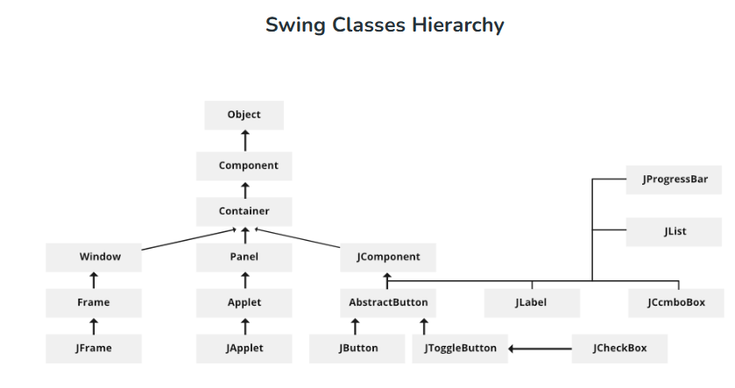

**MySQL**

MySQL is an open-source, Relational Database Management System that stores data in a structured format using rows and columns. It’s software that enables users to create, manage, and manipulate databases. Developed by MySQL AB, which is now owned by Oracle Corporation, MySQL is renowned for its reliability, scalability, and ease of use.

**USE OF MYSQL**

MySQL is a popular choice for managing relational databases for several reasons:

**Open Source:** MySQL is open-source software, which means it’s free to use and has a large community of developers contributing to its improvement.

**Relational:** MySQL follows the relational database model, allowing users to organize data into tables with rows and columns, facilitating efficient data storage and retrieval.

**Reliability:** MySQL has been around for a long time and is known for its stability and reliability.

**Performance:**MySQL is optimized for performance, making it capable of handling high-volume transactions and large datasets efficiently.

**Scalability:** MySQL can scale both vertically and horizontally to accommodate growing data and user loads. You can add more resources to a single server or distribute the workload across multiple servers using techniques like sharding or replication.

**Compatibility:** MySQL is widely supported by many programming languages, frameworks, and tools. It offers connectors and APIs for popular languages like PHP, Python, Java, and more, making it easy to integrate with your existing software stack.

**Security:**MySQL provides robust security features to protect your data, including access controls, encryption, and auditing capabilities. With proper configuration, you can ensure that only authorized users have access to sensitive information.

**APPLICATION OF MySQL**

* E-commerce: MySQL is extensively used in e-commerce platforms for managing product catalogs, customer data, orders, and transactions.
* Content Management Systems (CMS): Many popular CMS platforms rely on MySQL as their backend database to store website content, user profiles, comments, and configuration settings.
* Financial Services: MySQL is employed in financial applications, including banking systems, payment processing platforms, and accounting software, to manage transactional data, customer accounts, and financial records.
* Healthcare: MySQL is used in healthcare applications for storing and managing patient records, medical histories, treatment plans, and diagnostic information.
* Social Media: MySQL powers the backend databases of many social media platforms, including user profiles, posts, comments, likes, and connections.

**SYSTEM ANALYSIS**

**ENTITY RELATION DIAGRAMS**

The Entity Relation Model or Entity Relation Diagram (ERD) is a data model or diagram for high-level description of conceptual data model, and it provides a graphical notation for representing such data models in the form of entity relationship diagrams. Such models are typically used in the first stage of Management information system design; they are used for example, to describe information needs and/ or the type of information that is to be stored in the Database during the requirement analysis. The data modelling technique, however, can be used to describe any ontology (i.e. an overview and classification of used term and their relationships) for a certain universe of discourse (i.e. area of interest).

In the case of design a Management Information System that is based on a database, the conceptual data model is, a later stage (usually called logical design), mapped to a logical data model such as, relational data model; this is turn in mapped to a physical model during physical design. Note that sometimes, both of the phases are referred a “physical design”. There are number of convention for entity-relation diagrams (ERDs). The classical notation is describe in the remainder of this article, and mainly related to the conceptual modelling. There is a range of notation more typically employed in physical and logical database design.

**Key components of an ERD**:

**Entity:**

* Represents a thing that can have data stored about it (e.g., a car, a person, an address, or a student enrolment).
* Entities are usually depicted as rectangles on the ERD, with the entity name inside.
* Entities can be either strong (with a primary key) or weak (dependent on another entity).

**Relationship:**

* Defines how two entities are related to each other.
* Represented as lines connecting entities, often labelled (e.g., “enrols,” “registers,” or “completes”).
* Types of relationships include one-to-one, one-to-many, and many-to-many.

**Attribute:**

* Describes a property of an entity (e.g., an attribute of a student could be their name or enrolment date).
* Attributes are often represented as ovals or entries within an entity.
* ERDs help developers understand the structure of a database during system design and can be created for both new and existing systems. They play a crucial role in ensuring data integrity and providing a blueprint for developers

**ENTITY RELATIONSHIP DIAG**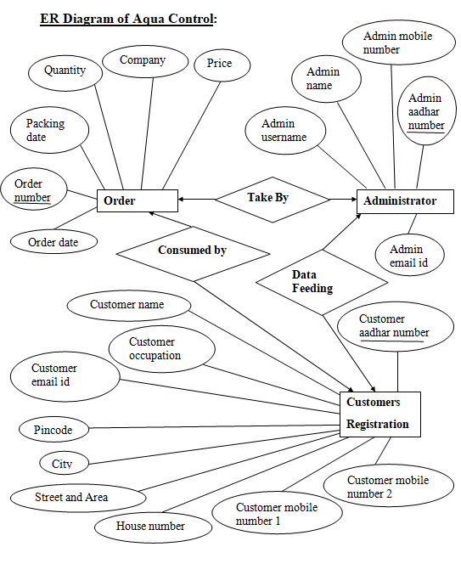

**DATA FLOW DIAGRAM**

The data flow diagram shows the flow of data within any system. It is an important tool for designing phase of software engineering. Larry Constantine first developed it. It represents graphical view of flow of data. It’s also known as BUBBLE CHART. The purpose of DFD is major transformation that will become in system design symbols used in DFD.

In the DFD, four symbols are used and they are as follows.

1.A square defines a source (originator) or destination of system data.

2.An arrow identifies data flow-data in motion. It is 2a pipeline through which information flows.

3.A circle or a “bubble “(Some people use an oval bubble) represents a process that transfers informing data flows into outgoing data flows.

4.An open rectangle is a data store-data at rest, or a temporary

repository of data.

**Context Level Data Flow Diagram**

This level shows the overall context of the system and its operating environment and shows the whole system as just one process. Online book store is shown as one process in the context diagram; which is also known as zero level DFD, shown below. The context diagram plays important role in understanding the system and determining the boundaries. The main process can be broken into sub-processes and system can be studied with more detail; this is where 1st level DFD comes into play.

PRODUCT

(WATER)

CUSTOMER

Request

Fulfillment Update customer

ADMIN

**Maintain Aqua supply**

**Zero Level Data Flow Diagram**

**First Level DFD**

This level (level 1) shows all processes at the first level of numbering, data stores, external entities and the data flows between them. The purpose of this level is to show the major high-level processes of the system and their interrelation. A process model will have one, and only one, level-1 diagram. A level-1 diagram must be balanced with its parent context level diagram, i.e. there must be the same external entities and the same data flows, these can be broken down to more detail in the level 1

Customer Details

Customer DB

ADMIN

Stock DB

Stock Details

Stock DB

Order Product

Report DB

Generate Report

Report DB

Bill Generate

**Data Tables**

**1.For Customer Form:**

|  |  |  |  |
| --- | --- | --- | --- |
| **COLUMN NAME** | **DATA TYPE** | **SIZE** | **CONTRAINTS** |
| aadhar | varchar | 20 | Not Null,Primary key |
| name | varchar | 30 | Not Null |
| occ | varchar | 20 | Not Null |
| email | varchar | 30 | Not Null |
| mob1 | varchar | 15 | Not Null |
| mob2 | varchar | 15 | Not Null |
| hno | varchar | 10 | Not Null |
| street | varchar | 15 | Not Null |
| pinc | varchar | 10 | Not Null |
| city | varchar | 10 | Not Null |

**2.For Administrator Form:**

|  |  |  |  |
| --- | --- | --- | --- |
| **COLUMN NAME** | **DATA TYPE** | **SIZE** | **CONTRAINTS** |
| aadhar | varchar | 20 | Not Null,Primary key |
| name | varchar | 30 | Not Null |
| phone | varchar | 15 | Not Null |
| email | varchar | 30 | Not Null |
| user | varchar | 20 | Not Null |

**3.For Login Form:**

|  |  |  |  |
| --- | --- | --- | --- |
| **COLUMN NAME** | **DATA TYPE** | **SIZE** | **CONSTRAINTS** |
| user | varchar | 30 | Not null |
| pass | varchar | 30 | Not null |

**4.For Order Form:-**

|  |  |  |  |
| --- | --- | --- | --- |
| **COLUMN NAME** | **DATA TYPE** | **SIZE** | **CONTRAINTS** |
| com | varchar | 20 | Not Null |
| quan | varchar | 10 | Not Null |
| price | varchar | 10 | Not Null |
| pack | varchar | 15 | Not Null |
| name | varchar | 30 | Not Null |
| mob | varchar | 15 | Not Null |
| ordno | varchar | 10 | NotNull, Primary key |
| orddate | varchar | 15 | Not Null |

**5.For Stock Form:-**

|  |  |  |  |
| --- | --- | --- | --- |
| **COLUMN NAME** | **DATA TYPE** | **SIZE** | **CONSTRAINTS** |
| comp | varchar | 20 | Not Null |
| quan | varchar | 10 | Not Null |
| price | varchar | 10 | Not Null |
| pack | varchar | 15 | Not Null |

**MODULE**

**LOGIN:** This module has attributes as admin username and password. Through this admin can add customer’s details, manage customer’ details, add stock, manage stock, place order for customers, generate daily reports and admin can add new admin etc.

**ORDER:** In this module information about the product i.e. type of water, price, quantity are mentioned, that will help the customer to easily place their orders and after placing bill is generated.

**ADVANTAGES:-**

1. This provides an optimal solution to the water supply.
2. Maintaining the water supply.
3. Water supply for specific period of time.
4. Unnecessary waste of water.
5. Customers can easily pay their bills.
6. Customers can also check their status.

**LIMITATIONS:-**

1. If customer does not have computer knowledge they will face problems and will not get the advantages of this project.
2. Limited amount of water.
3. Lack of awareness in the society about water resources.

**PROJECT SCREEN SHORT**

1. **Splash Screen:**

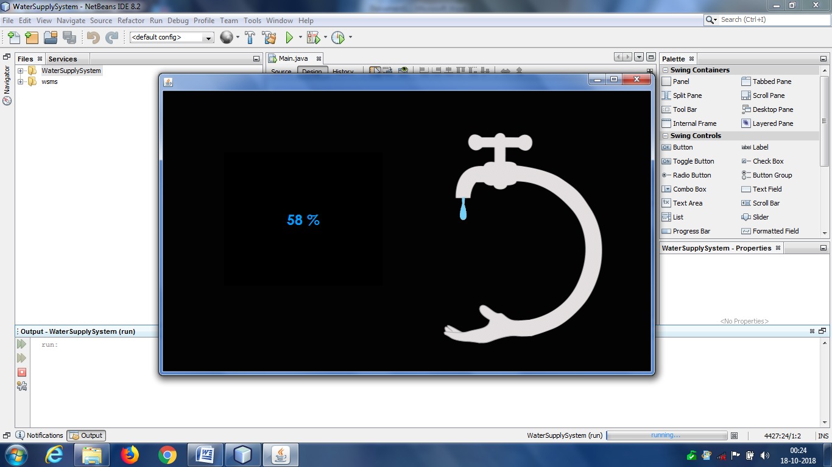

1. **Login:**

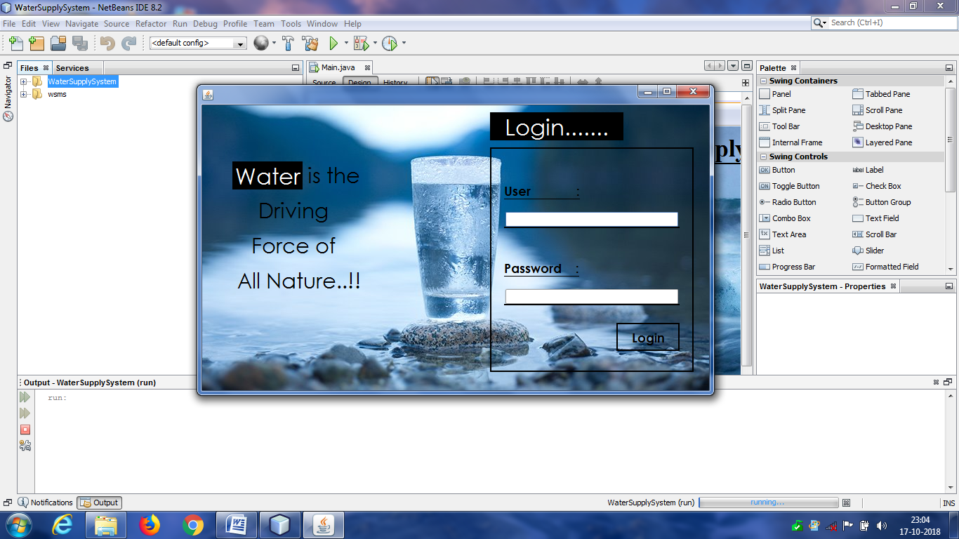

1. **Home Screen:**

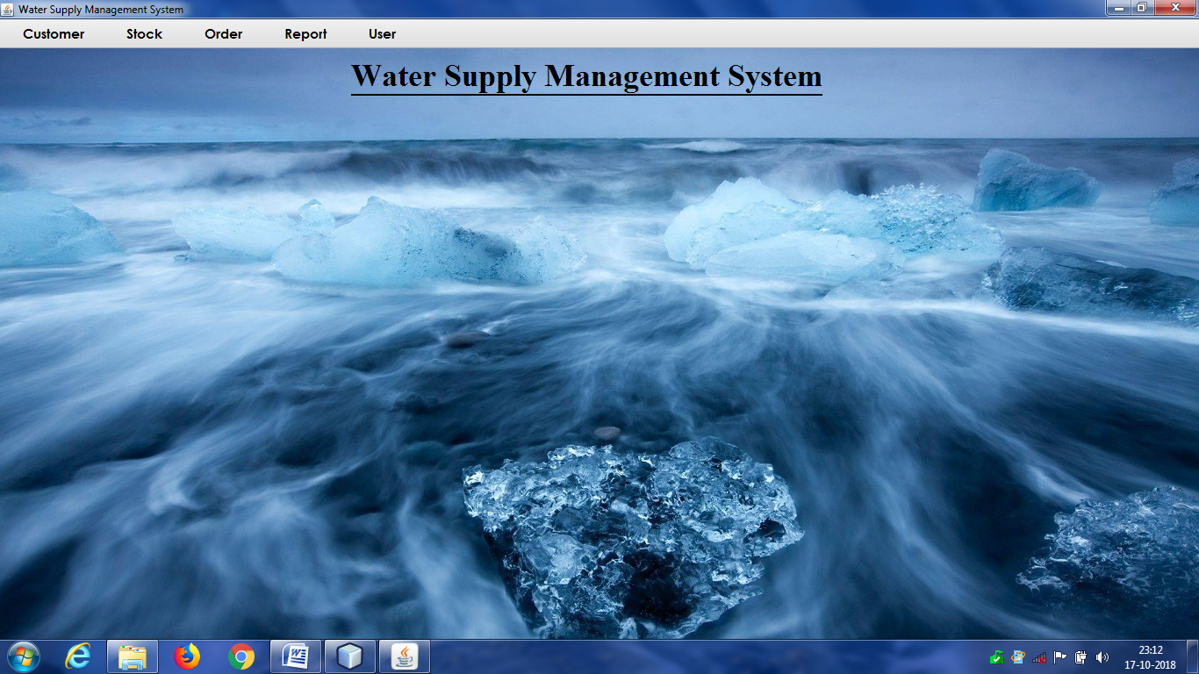

**Menus:**

a. Customer- (Add, Update, Delete, Search/View Customer)

b. Stock- (Add, Modify, Delete, Search/View Stock)

c. Order- (Order, View Order by Bill No.)

d. Report- (Customer wise, Date wise, Month wise, Year wise)

e. User- (Add Admin, Update/Delete Admin, Logout, Exit, Change Password)

1. **Add Customer:**

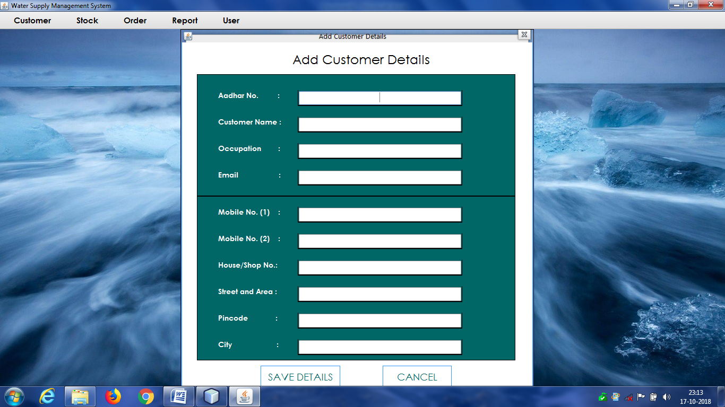

1. **Update Customer:**

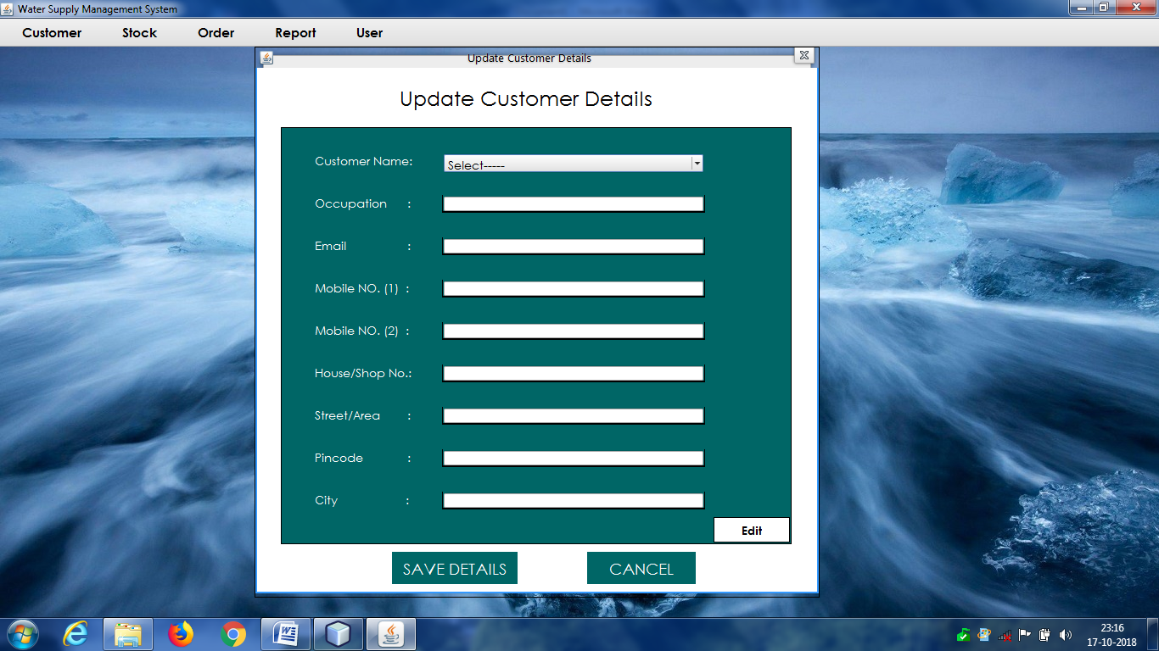

1. **Delete Customer:**

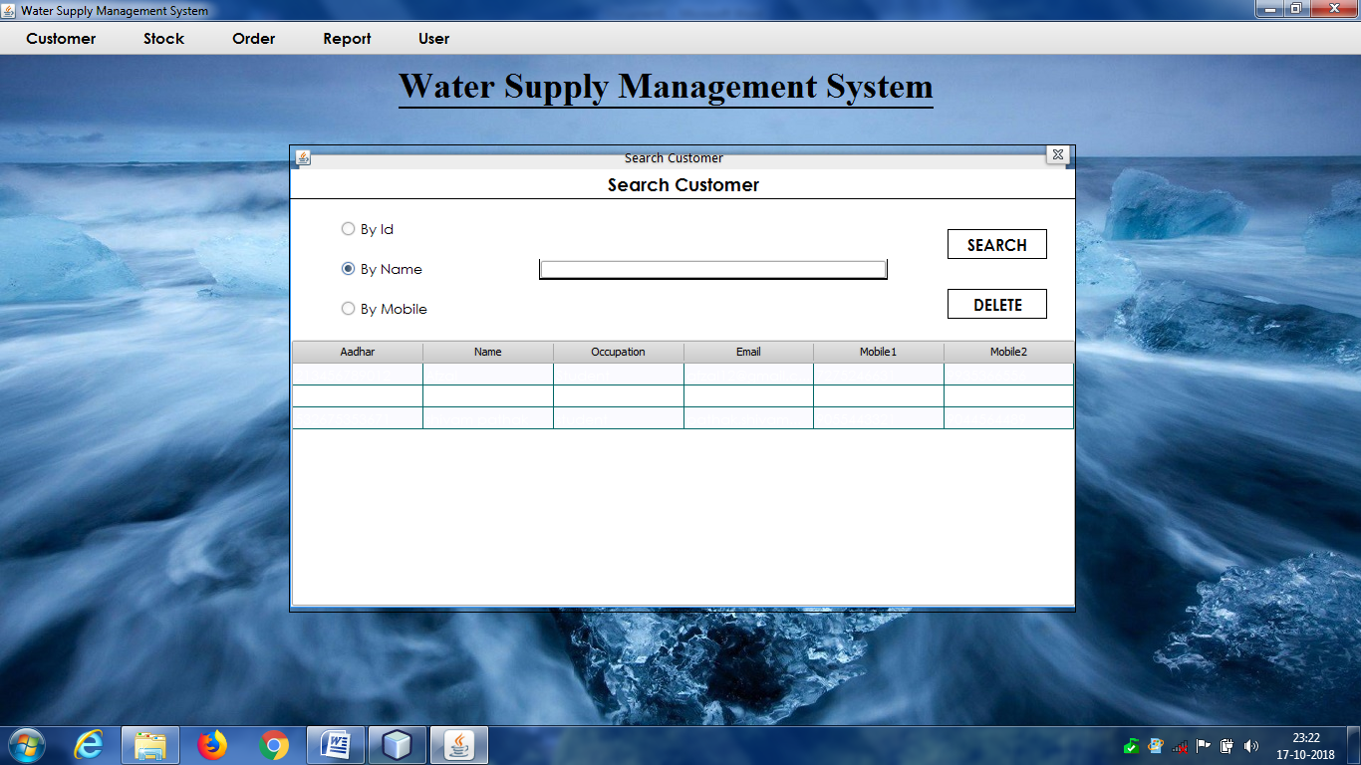

1. **Search Customer:**

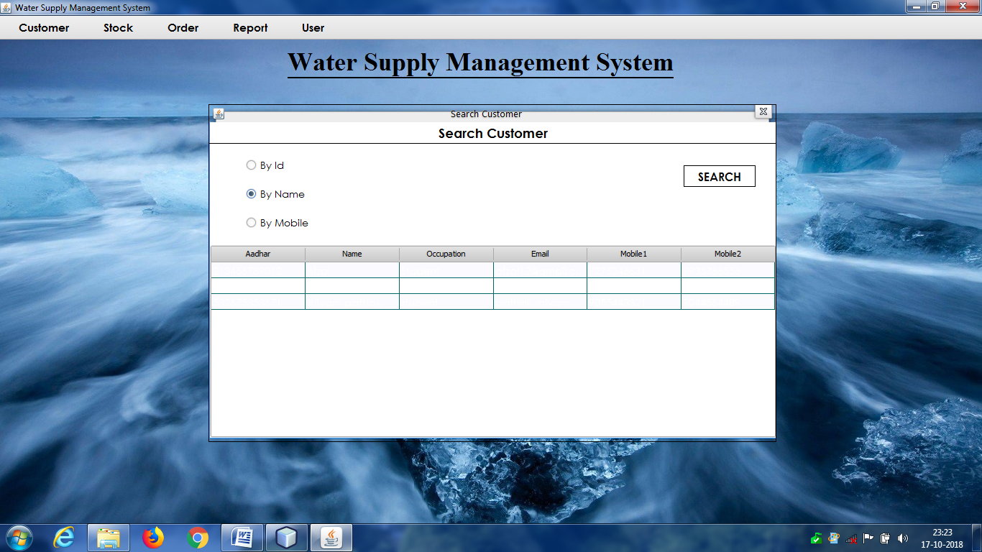

1. **Add Stock:**

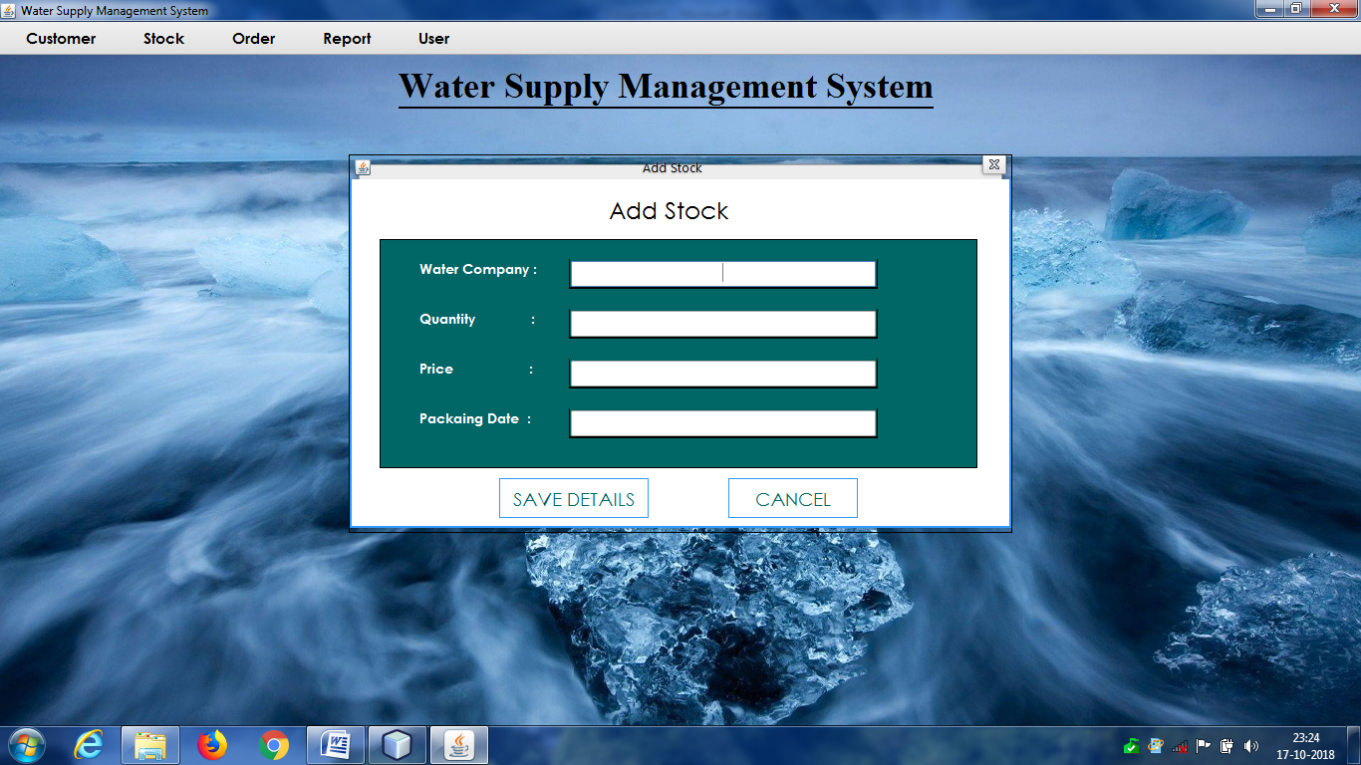

1. **Update Stock:**

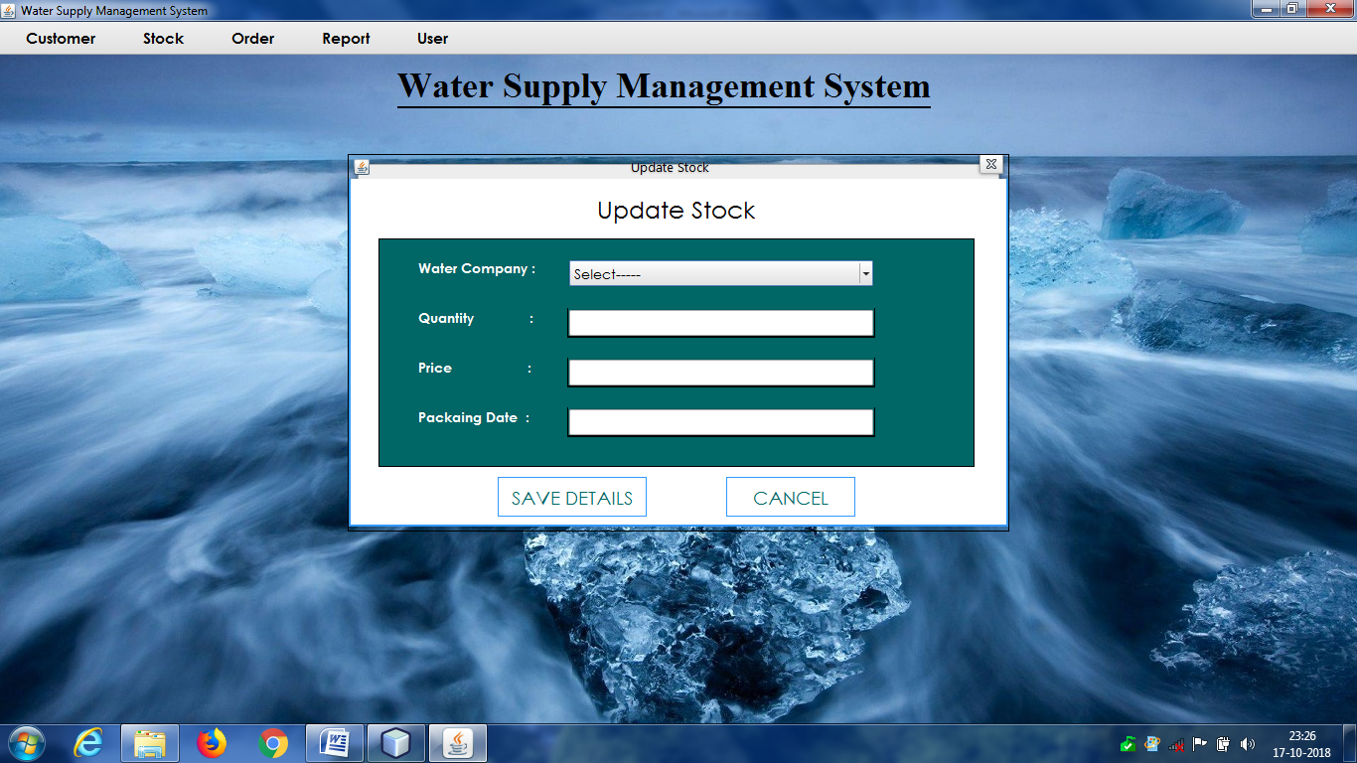

1. **Delete Stock:**

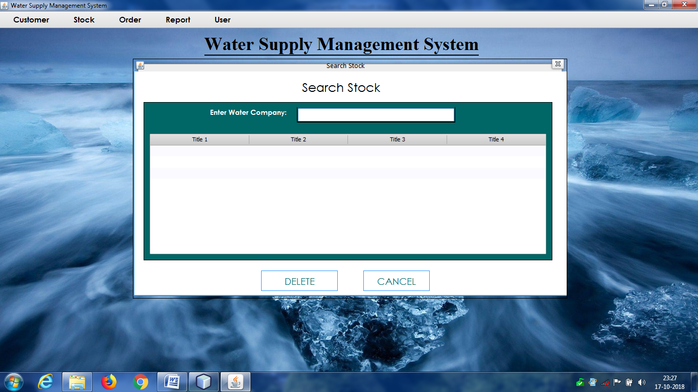

1. **Search Stock:**

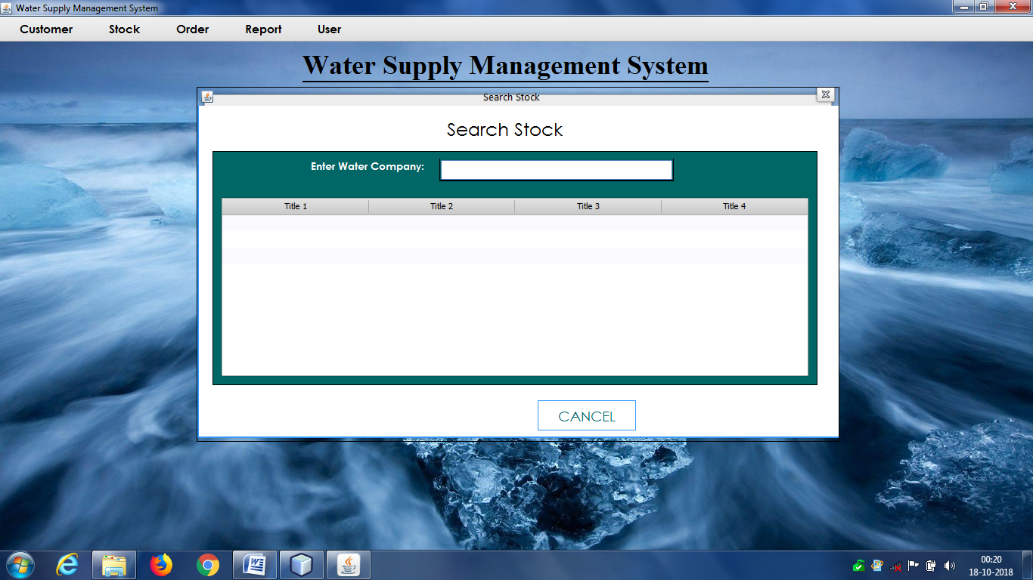

1. **Take Order:**

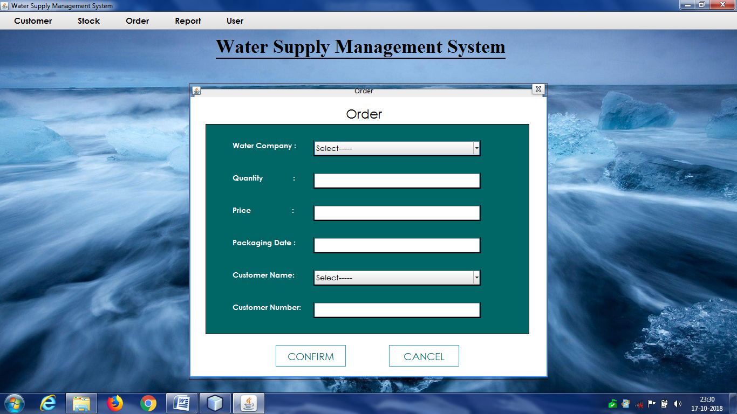

1. **Bill:**

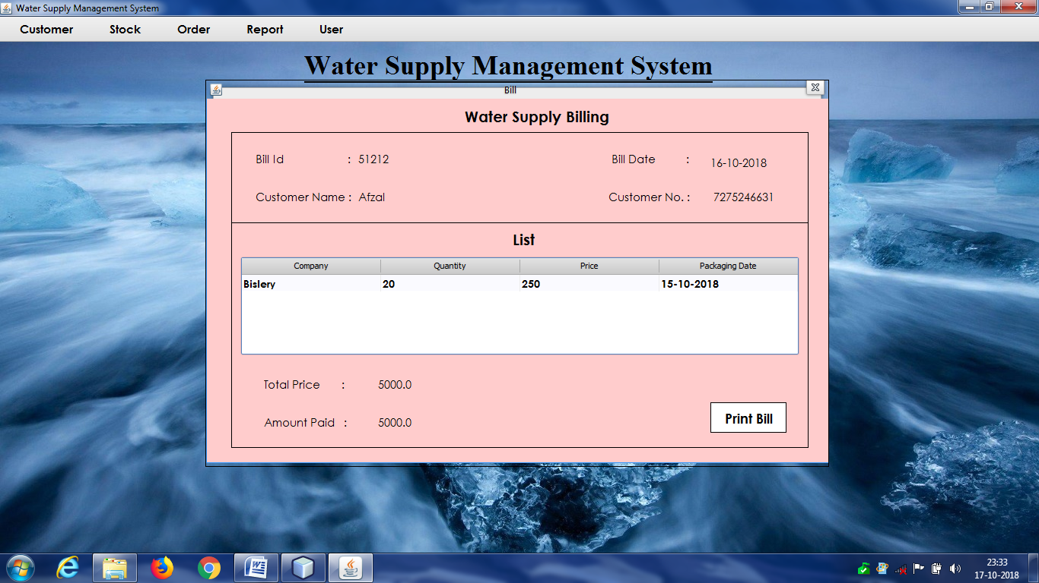

1. **View Order:**

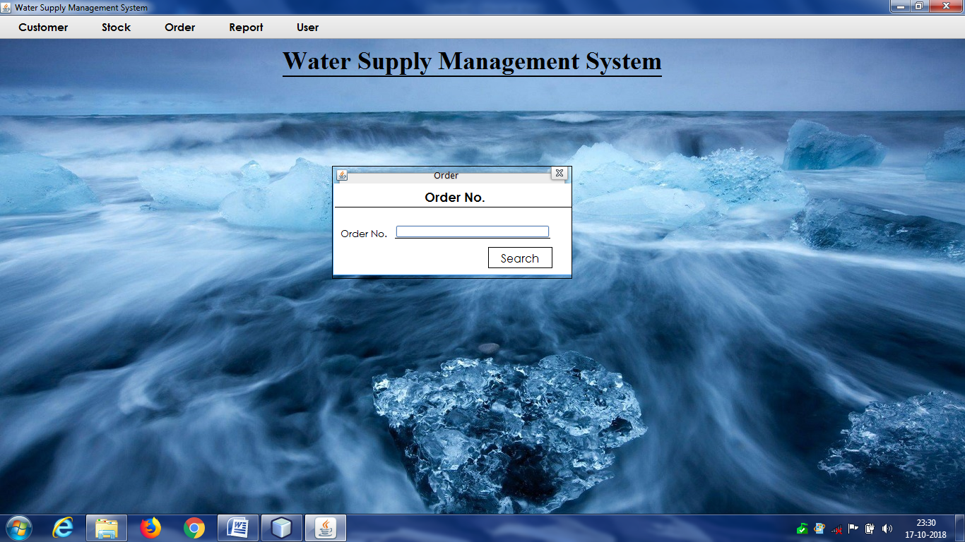

1. **Report (Customer wise):**

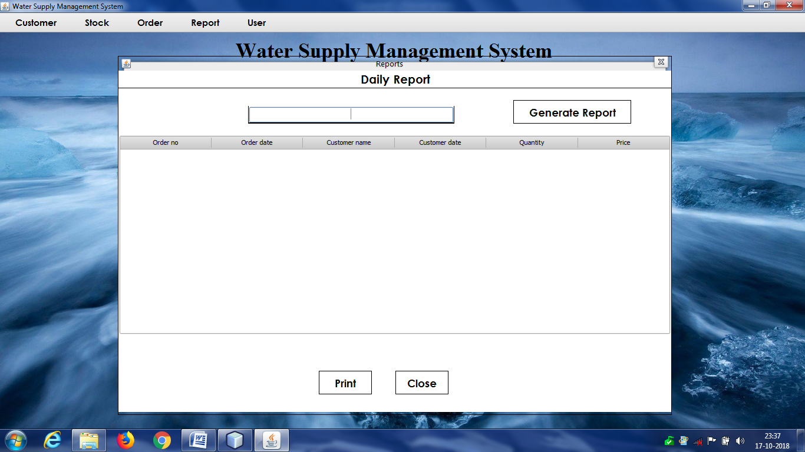

1. **Report (Date Wise):**

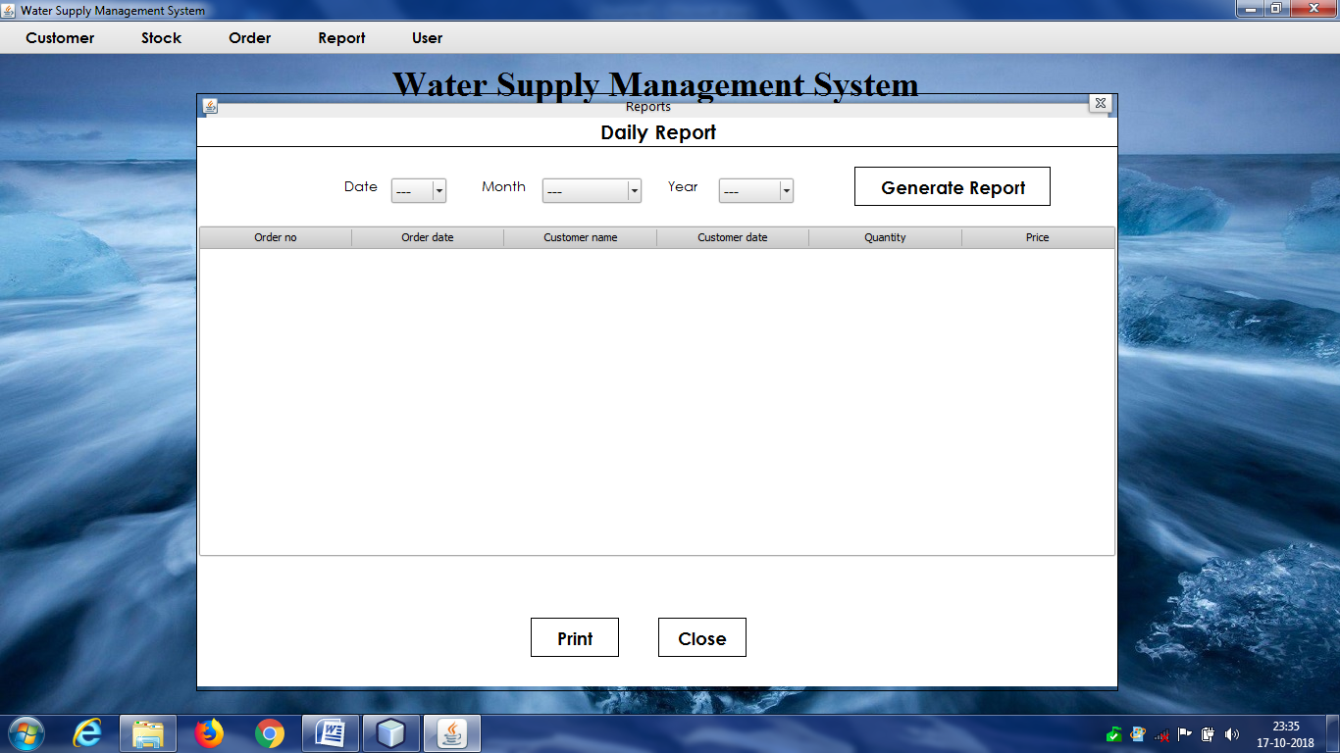

1. **Report (monthly Wise):**

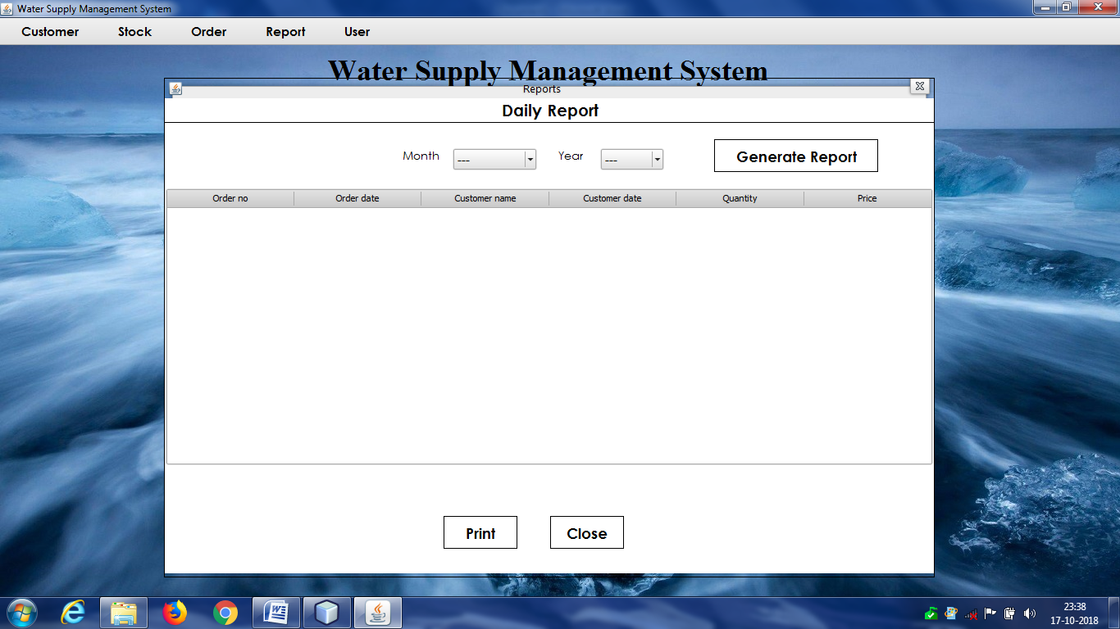

1. **Report(Yearly Wise):**

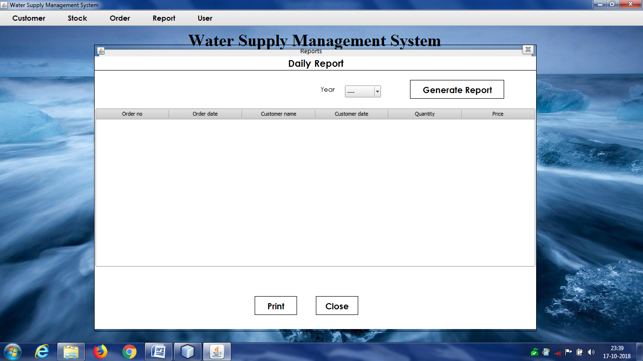

1. **Add Admin:**

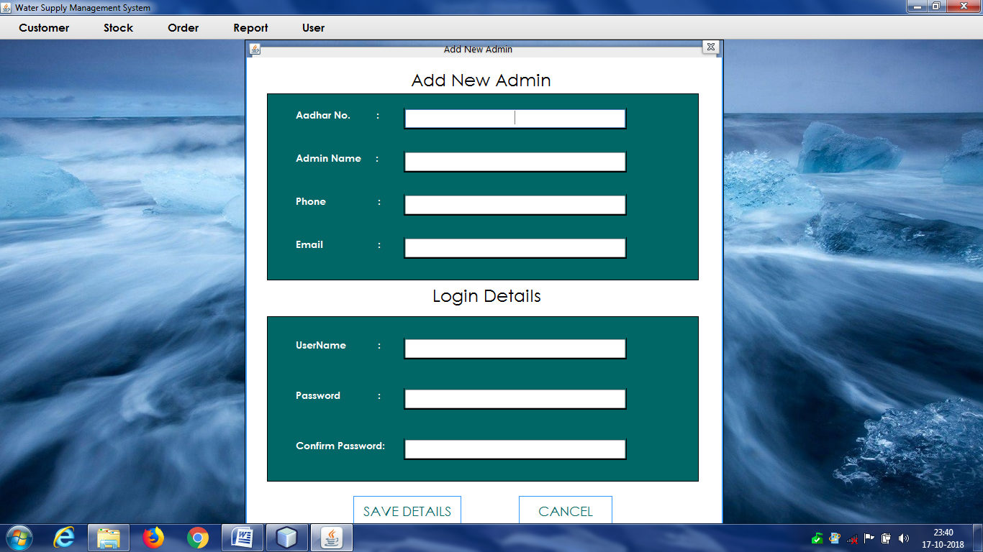

1. **Update/Delete Admin:**

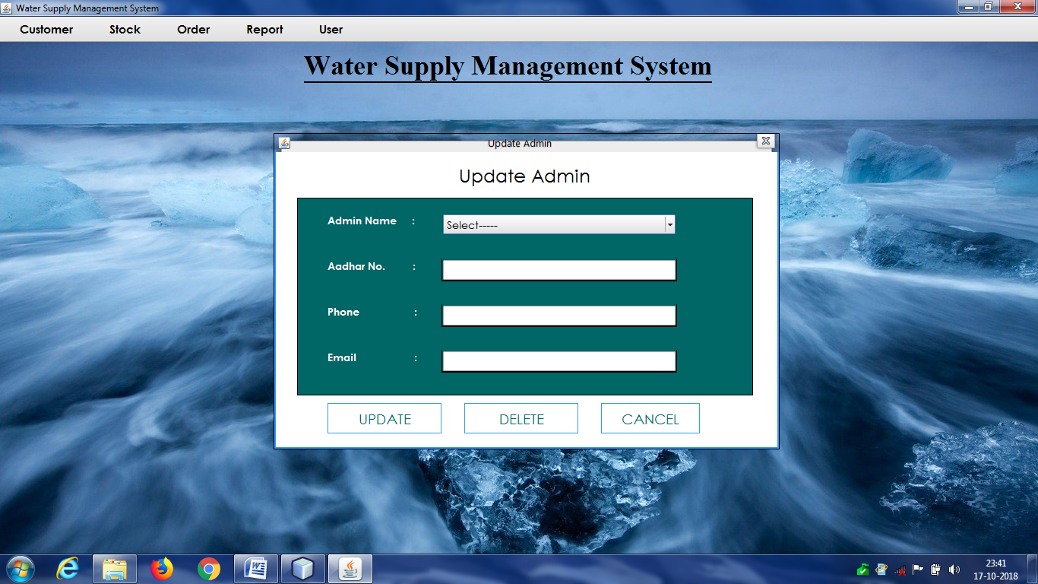

1. **Change Password:**

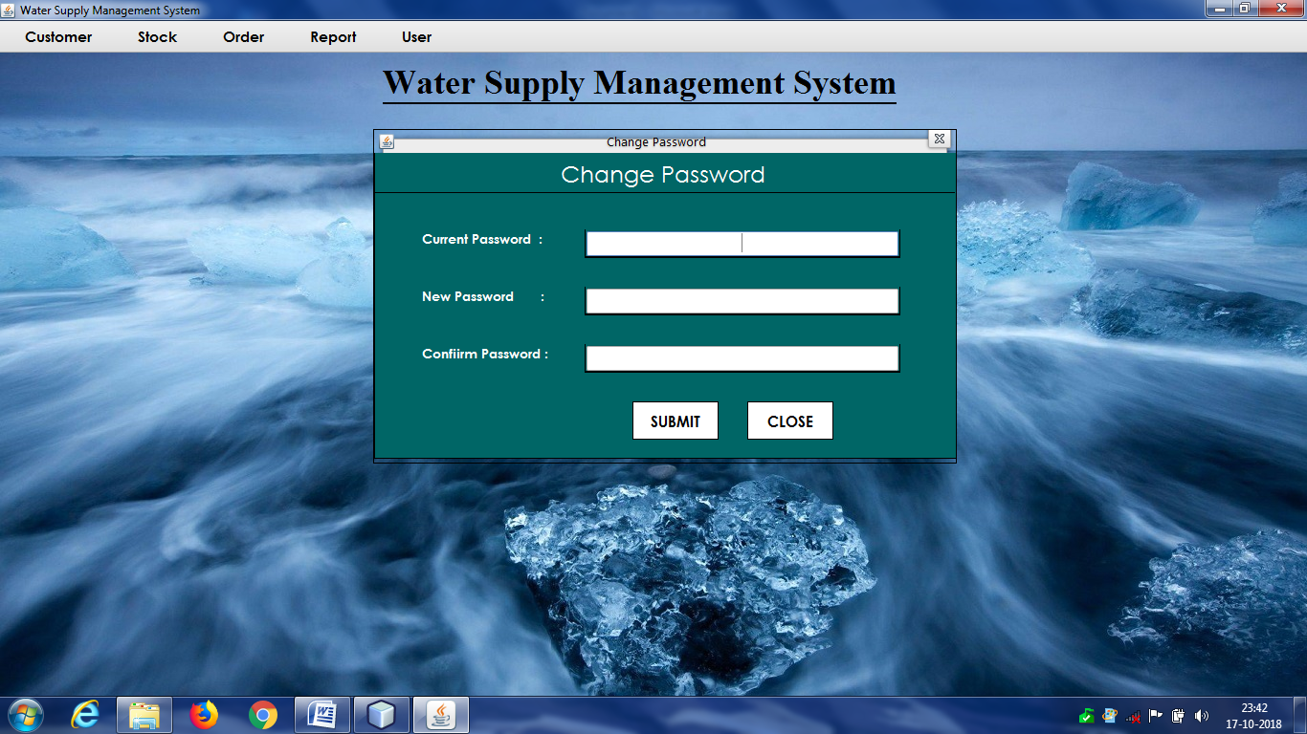

**PROJECT CODE**

**//SPLASH SCREEN CODE**

package watersupplysystem;

import java.util.logging.Level;

import java.util.logging.Logger;

/**

* @author Afzal

*/

public class Splash extends javax.swing.JFrame

{

/**

* Creates new form Splash

*/

public Splash()

{

initComponents();

setLocation(260,120);

// for(int i=1;i<=100;i++)

// {

// jLabel2.setText(i+" %");

// try

{

// Thread.sleep(25);

// }

catch (InterruptedException ex)

{

// Logger.getLogger(Splash.class.getName()).log(Level.SEVERE, null, ex);

// }

// }

//

}

/**

* This method is called from within the constructor to initialize the form.

* WARNING: Do NOT modify this code. The content of this method is always

* regenerated by the Form Editor.

*/

@SuppressWarnings("unchecked")

// <editor-fold defaultstate="collapsed" desc="Generated Code">

private void initComponents()

{

jPanel1 = new javax.swing.JPanel();

jLabel2 = new javax.swing.JLabel();

jLabel1 = new javax.swing.JLabel();

setDefaultCloseOperation(javax.swing.WindowConstants.EXIT_ON_CLOSE);

jPanel1.setLayout(new org.netbeans.lib.awtextra.AbsoluteLayout());

jLabel2.setBackground(new java.awt.Color(0, 0, 0));

jLabel2.setFont(new java.awt.Font("Century Gothic", 1, 24));

jLabel2.setForeground(new java.awt.Color(0, 153, 255)); jLabel2.setHorizontalAlignment(javax.swing.SwingConstants.CENTER);

jLabel2.setText("100%");

jLabel2.setOpaque(true);

jPanel1.add(jLabel2, new org.netbeans.lib.awtextra.AbsoluteConstraints(100, 100, 260, 220));

jLabel1.setHorizontalAlignment(javax.swing.SwingConstants.CENTER);

jLabel1.setIcon(new javax.swing.ImageIcon(getClass().getResource("/watersupplysystem/save_water_1.gif")));

jPanel1.add(jLabel1, new org.netbeans.lib.awtextra.AbsoluteConstraints(0, 0, -1, 460));

javax.swing.GroupLayout layout = new javax.swing.GroupLayout(getContentPane());

getContentPane().setLayout(layout);

layout.setHorizontalGroup( layout.createParallelGroup(javax.swing.GroupLayout.Alignment.LEADING)

.addComponent(jPanel1, javax.swing.GroupLayout.PREFERRED_SIZE,

javax.swing.GroupLayout.DEFAULT_SIZE, javax.swing.GroupLayout.PREFERRED_SIZE)

);

layout.setVerticalGroup( layout.createParallelGroup(javax.swing.GroupLayout.Alignment.LEADING)

.addComponent(jPanel1, javax.swing.GroupLayout.PREFERRED_SIZE, javax.swing.GroupLayout.DEFAULT_SIZE, javax.swing.GroupLayout.PREFERRED_SIZE)

);

pack();

}// </editor-fold>

/**

* @param args the command line arguments

*/

public static void main(String args[])

{

/* Set the Nimbus look and feel */

//<editor-fold defaultstate="collapsed" desc=" Look and feel setting code (optional) ">

/* If Nimbus (introduced in Java SE 6) is not available, stay with the default look and feel.

* For details see http://download.oracle.com/javase/tutorial/uiswing/lookandfeel/plaf.html

*/

try

{

for (javax.swing.UIManager.LookAndFeelInfo info : javax.swing.UIManager.getInstalledLookAndFeels()) {

if ("Nimbus".equals(info.getName()))

{ javax.swing.UIManager.setLookAndFeel(info.getClassName());

break;

}

}

}

catch (ClassNotFoundException ex)

{ java.util.logging.Logger.getLogger(Splash.class.getName()).log(java.util.logging.Level.SEVERE, null, ex);

}

catch (InstantiationException ex)

{ java.util.logging.Logger.getLogger(Splash.class.getName()).log(java.util.logging.Level.SEVERE, null, ex);

}

catch (IllegalAccessException ex)

{ java.util.logging.Logger.getLogger(Splash.class.g

etName()).log(java.util.logging.Level.SEVERE, null, ex);

}

catch (javax.swing.UnsupportedLookAndFeelException ex)

{ java.util.logging.Logger.getLogger(Splash.class.getName()).log(java.util.logging.Level.SEVERE, null, ex);

}

//</editor-fold>

/* Create and display the form */

java.awt.EventQueue.invokeLater(new Runnable()

{

public void run()

{

new Splash().setVisible(true);

}

});

}

// Variables declaration - do not modify

private javax.swing.JLabel jLabel1;

public javax.swing.JLabel jLabel2;

private javax.swing.JPanel jPanel1;

// End of variables declaration

}

**//DATABASE CONNECTION CODE**

package DB;

import java.sql.*;

public class DBConnection

{

public Connection con;

public Statement stmt;

public PreparedStatement pstmt;

public ResultSet rst;

public DBConnection()

{

try

{

Class.forName("com.mysql.jdbc.Driver");

con=DriverManager.getConnection("jdbc:mysql://localhost:3306/watersupply","root","root");

}

catch(Exception e)

{

e.printStackTrace();

}

}

}

**//LOGIN WINDOW CODE**

package watersupplysystem;

import DB.DBConnection;

import java.awt.Color;

import javax.swing.JOptionPane;

/**

* @author Afzal

*/

public class Login extends javax.swing.JFrame

{

/**

* Creates new form Login

*/

public Login()

{

initComponents();

setLocation(280,120);

}

/**

* This method is called from within the constructor to initialize the form.

* WARNING: Do NOT modify this code. The content of this method is always

* regenerated by the Form Editor.

*/

@SuppressWarnings("unchecked")

// <editor-fold defaultstate="collapsed" desc="Generated Code">

private void initComponents()

{

jPanel1 = new javax.swing.JPanel();

jLabel2 = new javax.swing.JLabel();

jLabel3 = new javax.swing.JLabel();

jLabel5 = new javax.swing.JLabel();

jLabel4 = new javax.swing.JLabel();

jLabel6 = new javax.swing.JLabel();

jLabel8 = new javax.swing.JLabel();

jLabel9 = new javax.swing.JLabel();

jTextField1 = new javax.swing.JTextField();

jLabel10 = new javax.swing.JLabel();

jPasswordField1 = new javax.swing.JPasswordField();

jLabel11 = new javax.swing.JLabel();

jLabel7 = new javax.swing.JLabel();

jLabel1 = new javax.swing.JLabel(); setDefaultCloseOperation(javax.swing.WindowConstants.EXIT_ON_CLOSE);

jPanel1.setLayout(new org.netbeans.lib.awtextra.AbsoluteLayout());

jLabel2.setFont(new java.awt.Font("Century Gothic", 0, 30));

jLabel2.setText("is the");

jPanel1.add(jLabel2, new org.netbeans.lib.awtextra.AbsoluteConstraints(150, 80, -1, -1));

jLabel3.setFont(new java.awt.Font("Century Gothic", 0, 30));

jLabel3.setText("Driving");

jPanel1.add(jLabel3, new org.netbeans.lib.awtextra.AbsoluteConstraints(80, 130, -1, -1));

jLabel5.setFont(new java.awt.Font("Century Gothic", 0, 30));

jLabel5.setText("Force of");

jPanel1.add(jLabel5, new org.netbeans.lib.awtextra.AbsoluteConstraints(70, 180, -1, -1));

jLabel4.setFont(new java.awt.Font("Century Gothic", 0, 30));

jLabel4.setText("All Nature..!!");

jPanel1.add(jLabel4, new org.netbeans.lib.awtextra.AbsoluteConstraints(50, 230, -1, -1));

jLabel6.setBackground(new java.awt.Color(0, 0, 0));

jLabel6.setFont(new java.awt.Font("Century Gothic", 0, 32));

jLabel6.setForeground(new java.awt.Color(255, 255, 255)); jLabel6.setHorizontalAlignment(javax.swing.SwingConstants.CENTER);

jLabel6.setText("Login.......");

jLabel6.setOpaque(true);

jPanel1.add(jLabel6, new org.netbeans.lib.awtextra.AbsoluteConstraints(410, 10, 190, -1));

jLabel8.setBackground(new java.awt.Color(0, 0, 0));

jLabel8.setFont(new java.awt.Font("Century Gothic", 0, 32));

jLabel8.setForeground(new java.awt.Color(255, 255, 255)); jLabel8.setHorizontalAlignment(javax.swing.SwingConstants.CENTER);

jLabel8.setText("Water");

jLabel8.setOpaque(true);

jPanel1.add(jLabel8, new org.netbeans.lib.awtextra.AbsoluteConstraints(43, 80, 100, -1));

jLabel9.setFont(new java.awt.Font("Century Gothic", 1, 18));

jLabel9.setText("User :"); jLabel9.setBorder(javax.swing.BorderFactory.createMatteBorder(0, 0, 1, 0, new java.awt.Color(0, 0, 0)));

jPanel1.add(jLabel9, new org.netbeans.lib.awtextra.AbsoluteConstraints(430, 110, -1, -1));

jTextField1.setFont(new java.awt.Font("Century Gothic", 1, 18)); jTextField1.setHorizontalAlignment(javax.swing.JTextField.CENTER); jTextField1.setBorder(javax.swing.BorderFactory.createMatteBorder(0, 0, 2, 0, new java.awt.Color(0, 0, 0)));

jTextField1.setOpaque(false);

jPanel1.add(jTextField1, new org.netbeans.lib.awtextra.AbsoluteConstraints(430, 150, 250, -1));

jLabel10.setFont(new java.awt.Font("Century Gothic", 1, 18));

jLabel10.setText("Password :"); jLabel10.setBorder(javax.swing.BorderFactory.createMatteBorder(0, 0, 1, 0, new java.awt.Color(0, 0, 0)));

jPanel1.add(jLabel10, new org.netbeans.lib.awtextra.AbsoluteConstraints(430, 220, -1, -1));

jPasswordField1.setFont(new java.awt.Font("Century Gothic", 1, 18)); jPasswordField1.setHorizontalAlignment(javax.swing.JTextField.CENTER); jPasswordField1.setBorder(javax.swing.BorderFactory.createMatteBorder(0, 0, 2, 0, new java.awt.Color(0, 0, 0)));

jPasswordField1.setOpaque(false);

jPanel1.add(jPasswordField1, new org.netbeans.lib.awtextra.AbsoluteConstraints(430, 260, 250, -1));

jLabel11.setFont(new java.awt.Font("Century Gothic", 1, 18)); jLabel11.setHorizontalAlignment(javax.swing.SwingConstants.CENTER);

jLabel11.setText("Login"); jLabel11.setBorder(javax.swing.BorderFactory.createLineBorder(new java.awt.Color(0, 0, 0), 2));

jLabel11.addMouseListener(new java.awt.event.MouseAdapter()

{

public void mouseClicked(java.awt.event.MouseEvent evt)

{

jLabel11MouseClicked(evt);

}

public void mouseEntered(java.awt.event.MouseEvent evt)

{

jLabel11MouseEntered(evt);

}

public void mouseExited(java.awt.event.MouseEvent evt)

{

jLabel11MouseExited(evt);

}

});

jPanel1.add(jLabel11, new org.netbeans.lib.awtextra.AbsoluteConstraints(590, 310, 90, 40)); jLabel7.setHorizontalAlignment(javax.swing.SwingConstants.CENTER);

jLabel7.setBorder(javax.swing.BorderFactory.createLineBorder(new java.awt.Color(0, 0, 0), 2));

jPanel1.add(jLabel7, new org.netbeans.lib.awtextra.AbsoluteConstraints(410, 60, 290, 320));

jLabel1.setHorizontalAlignment(javax.swing.SwingConstants.CENTER);

jLabel1.setIcon(new javax.swing.ImageIcon(getClass().getResource("/watersupplysystem/loginwater.jpg")));

jPanel1.add(jLabel1, new org.netbeans.lib.awtextra.AbsoluteConstraints(0, 0, -1, -1));

javax.swing.GroupLayout layout = new javax.swing.GroupLayout(getContentPane());

getContentPane().setLayout(layout);

layout.setHorizontalGroup( layout.createParallelGroup(javax.swing.GroupLayout.Alignment.LEADING) .addGroup(layout.createSequentialGroup()

.addComponent(jPanel1, javax.swing.GroupLayout.PREFERRED_SIZE, javax.swing.GroupLayout.DEFAULT_SIZE, javax.swing.GroupLayout.PREFERRED_SIZE)

.addGap(0, 0, Short.MAX_VALUE))

);

layout.setVerticalGroup(

layout.createParallelGroup(javax.swing.GroupLayout.Alignment.LEADING)

.addGroup(layout.createSequentialGroup()

.addComponent(jPanel1, javax.swing.GroupLayout.PREFERRED_SIZE, javax.swing.GroupLayout.DEFAULT_SIZE, javax.swing.GroupLayout.PREFERRED_SIZE)

.addGap(0, 0, Short.MAX_VALUE))

);

pack();

}// </editor-fold>

private void jLabel11MouseEntered(java.awt.event.MouseEvent evt)

{

jLabel11.setOpaque(true);

jLabel11.setBackground(Color.black);

jLabel11.setForeground(Color.white);

}

private void jLabel11MouseExited(java.awt.event.MouseEvent evt)

{

jLabel11.setOpaque(false);

jLabel11.setBackground(Color.white);

jLabel11.setForeground(Color.black);

}

private void jLabel11MouseClicked(java.awt.event.MouseEvent evt)

{

try

{

DBConnection db=new DBConnection();

db.pstmt=db.con.prepareStatement("select user,pass from login where user=? and pass=?");

db.pstmt.setString(1,jTextField1.getText());

db.pstmt.setString(2,jPasswordField1.getText());

db.rst=db.pstmt.executeQuery();

if(db.rst.next())

{

new Main(jTextField1.getText()).setVisible(true);

setVisible(false);

}

else

{

int g=JOptionPane.showConfirmDialog(this,"Want to

Exit?","Water Supply System",JOptionPane.YES_NO_OPTION);

if(g==0) {

System.exit(0);

}

else

{

}

}

} catch (Exception e)

{

e.printStackTrace();

}

}

/**

* @param args the command line arguments

*/

public static void main(String args[])

{

/* Set the Nimbus look and feel */

//<editor-fold defaultstate="collapsed" desc=" Look and feel setting code (optional) ">

/* If Nimbus (introduced in Java SE 6) is not available, stay with the default look and feel.

* For details see http://download.oracle.com/javase/tutorial/uiswing/lookandfeel/plaf.html

*/

try

{

for (javax.swing.UIManager.LookAndFeelInfo info : javax.swing.UIManager.getInstalledLookAndFeels())

{

if ("Windows".equals(info.getName()))

{

javax.swing.UIManager.setLookAndFeel(info.getClassName());

break;

}

}

}

catch (ClassNotFoundException ex)

{ java.util.logging.Logger.getLogger(Login.class.getName()).log(java.util.logging.Level.SEVERE, null, ex);

}

catch (InstantiationException ex)

{ java.util.logging.Logger.getLogger(Login.class.getName()).log(java.util.logging.Level.SEVERE, null, ex);

}

catch (IllegalAccessException ex)

{ java.util.logging.Logger.getLogger(Login.class.getName()).log(java.util.logging.Level.SEVERE, null, ex);

}

catch (javax.swing.UnsupportedLookAndFeelException ex)

{ java.util.logging.Logger.getLogger(Login.class.getName()).log(java.util.logging.Level.SEVERE, null, ex);

}

//</editor-fold>

/* Create and display the form */

java.awt.EventQueue.invokeLater(new Runnable()

{

public void run()

{

new Login().setVisible(true);

}

});

}

// Variables declaration - do not modify

private javax.swing.JLabel jLabel1;

private javax.swing.JLabel jLabel10;

private javax.swing.JLabel jLabel11;

private javax.swing.JLabel jLabel2;

private javax.swing.JLabel jLabel3;

private javax.swing.JLabel jLabel4;

private javax.swing.JLabel jLabel5;

private javax.swing.JLabel jLabel6;

private javax.swing.JLabel jLabel7;

private javax.swing.JLabel jLabel8;

private javax.swing.JLabel jLabel9;

private javax.swing.JPanel jPanel1;

private javax.swing.JPasswordField jPasswordField1;

private javax.swing.JTextField jTextField1;

// End of variables declaration

}

**//ALL MENU ITEMS CODE**

private void jMenuItem1ActionPerformed(java.awt.event.ActionEvent evt)

{

addcus.setVisible(true);

}

private void jMenuItem2ActionPerformed(java.awt.event.ActionEvent evt)

{

try

{

jComboBox3.removeAllItems();

int g=0;

DBConnection db=new DBConnection();

db.pstmt=db.con.prepareStatement("select name from cust");

db.rst=db.pstmt.executeQuery();

jComboBox3.addItem("Select-----");

while(db.rst.next())

{g++;

jComboBox3.addItem(db.rst.getString(1));

}

if(g==0)

{

JOptionPane.showMessageDialog(this,"No Data Found");

}

else

{

updatecustomer.setVisible(true);

}

}

catch (Exception e)

{

e.printStackTrace();

}

}

private void jMenuItem3ActionPerformed(java.awt.event.ActionEvent evt)

{

jLabel30.setVisible(true);

searchcus.setVisible(true);

jTextField20.setVisible(false);

jTextField21.setVisible(false);

jTextField22.setVisible(false);

jTextField20.setText("");

jTextField21.setText("");

jTextField22.setText("");

}

private void jMenuItem4ActionPerformed(java.awt.event.ActionEvent evt)

{

jLabel30.setVisible(false);

searchcus.setVisible(true);

jTextField20.setVisible(false);

jTextField21.setVisible(false);

jTextField22.setVisible(false);

jTextField20.setText("");

jTextField21.setText("");

jTextField22.setText("");

}

private void jMenuItem8ActionPerformed(java.awt.event.ActionEvent evt)

{

addstock.setVisible(true);

}

private void jMenuItem9ActionPerformed(java.awt.event.ActionEvent evt)

{

try

{

jComboBox1.removeAllItems();

int g=0;

DBConnection db=new DBConnection();

db.pstmt=db.con.prepareStatement("select comp from stock");

db.rst=db.pstmt.executeQuery();

jComboBox1.addItem("Select-----");

while(db.rst.next())

{

g++;

jComboBox1.addItem(db.rst.getString(1));

}

if(g==0)

{

JOptionPane.showMessageDialog(this,"No Data Found");

}

else

{

updatestock.setVisible(true);

}

}

catch (Exception e)

{

e.printStackTrace();

}

}

private void jMenuItem10ActionPerformed(java.awt.event.ActionEvent evt)

{

jLabel71.setVisible(true);

delstock.setVisible(true);

}

private void jMenuItem22ActionPerformed(java.awt.event.ActionEvent evt)

{

jLabel71.setVisible(false);

delstock.setVisible(true);

}

private void jMenuItem11ActionPerformed(java.awt.event.ActionEvent evt)

{

try

{

jComboBox2.removeAllItems();

int g=0;

DBConnection db=new DBConnection();

db.pstmt=db.con.prepareStatement("select comp from stock");

db.rst=db.pstmt.executeQuery();

jComboBox2.addItem("Select-----");

while(db.rst.next())

{

g++;

jComboBox2.addItem(db.rst.getString(1));

}

if(g==0)

{

JOptionPane.showMessageDialog(this,"No Data Found");

}

else

{

order.setVisible(true);

}

}

catch (Exception e)

{

e.printStackTrace();

}

try

{

jComboBox5.removeAllItems();

DBConnection db=new DBConnection();

db.pstmt=db.con.prepareStatement("select name from cust");

db.rst=db.pstmt.executeQuery();

jComboBox5.addItem("Select-----");

while(db.rst.next())

{

jComboBox5.addItem(db.rst.getString(1));

}

}

catch (Exception e)

{

e.printStackTrace();

}

}

private void jMenuItem12ActionPerformed(java.awt.event.ActionEvent evt)

{

searchbill.setVisible(true); jTextField33.setText("");

}

int rep=0;

private void jMenuItem13ActionPerformed(java.awt.event.ActionEvent evt)

{

jTextField4.setVisible(true);

date.setVisible(false);

month.setVisible(false);

year.setVisible(false);

jLabel83.setVisible(false);

jLabel84.setVisible(false);

jLabel85.setVisible(false);

report.setVisible(true);

rep=3;

}

private void jMenuItem14ActionPerformed(java.awt.event.ActionEvent evt)

{

rep=0;

jTextField4.setVisible(false);

date.setVisible(true);

month.setVisible(true);

year.setVisible(true);

jLabel83.setVisible(true);

jLabel84.setVisible(true);

jLabel85.setVisible(true);

report.setVisible(true);

}

private void jMenuItem15ActionPerformed(java.awt.event.ActionEvent evt)

{

jTextField4.setVisible(false);

date.setVisible(false);

month.setVisible(true);

year.setVisible(true);

jLabel83.setVisible(false);

jLabel84.setVisible(true);

jLabel85.setVisible(true);

report.setVisible(true);

rep=1;

}

private void jMenuItem16ActionPerformed(java.awt.event.ActionEvent evt)

{

rep=2;

jTextField4.setVisible(false);

date.setVisible(false);

month.setVisible(false);

year.setVisible(true);

jLabel83.setVisible(false);

jLabel84.setVisible(false);

jLabel85.setVisible(true);

report.setVisible(true);

}

private void jMenuItem17ActionPerformed(java.awt.event.ActionEvent evt)

{

addadmin.setVisible(true);

}

private void jMenuItem18ActionPerformed(java.awt.event.ActionEvent evt)

{

try

{

jComboBox4.removeAllItems();

int g=0;

DBConnection db=new DBConnection();

db.pstmt=db.con.prepareStatement("select name from admin");

db.rst=db.pstmt.executeQuery();

jComboBox4.addItem("Select-----");

while(db.rst.next())

{

g++;

jComboBox4.addItem(db.rst.getString(1));

}

if(g==0)

{

JOptionPane.showMessageDialog(this,"No Data Found");

}

else

{

updateadmin.setVisible(true);

}

}

catch (Exception e)

{

e.printStackTrace();

}

}

private void jMenuItem21ActionPerformed(java.awt.event.ActionEvent evt)

{

changepass.setVisible(true);}

private void jMenuItem19ActionPerformed(java.awt.event.ActionEvent evt)

{

int g=JOptionPane.showConfirmDialog(this,"Logout.??","Water Supply System",JOptionPane.YES_NO_OPTION);

if(g==0)

{

new Login().setVisible(true);

setVisible(false);

}

else

{

}

}

private void jMenuItem20ActionPerformed(java.awt.event.ActionEvent evt)

{

int g=JOptionPane.showConfirmDialog(this,"Exit.??","Water Supply System",JOptionPane.YES_NO_OPTION);

if(g==0)

{

System.exit(0);

}

else

{

}

}

**//ADD CUSTOMER CODE**

private void jLabel7MouseClicked(java.awt.event.MouseEvent evt)

{

try

{

DBConnection db=new DBConnection();

db.pstmt=db.con.prepareStatement("insert into cust values(?,?,?,?,?,?,?,?,?,?)");

db.pstmt.setString(1,jTextField1.getText());

db.pstmt.setString(2,jTextField3.getText());

db.pstmt.setString(3,jTextField2.getText());

db.pstmt.setString(4,jTextField5.getText());

db.pstmt.setString(5,jTextField6.getText());

db.pstmt.setString(6,jTextField7.getText());

db.pstmt.setString(7,jTextField8.getText());

db.pstmt.setString(8,jTextField9.getText()); db.pstmt.setString(9,jTextField10.getText());

db.pstmt.setString(10,jTextField11.getText());

int i=db.pstmt.executeUpdate();

if(i>0){ JOptionPane.showMessageDialog(this,"Successfully send to Database.");

jTextField1.setText("");

jTextField3.setText("");

jTextField2.setText("");

jTextField5.setText("");

jTextField6.setText("");

jTextField7.setText("");

jTextField8.setText("");

jTextField9.setText("");

jTextField10.setText("");

jTextField11.setText("");

}

}

catch (Exception e)

{

e.printStackTrace();

}}

private void jLabel6MouseClicked(java.awt.event.MouseEvent evt)

{

jTextField1.setText("");

jTextField3.setText("");

jTextField2.setText("");

jTextField5.setText("");

jTextField6.setText("");

jTextField7.setText("");

jTextField8.setText("");

jTextField9.setText("");

jTextField10.setText("");

jTextField11.setText("");

addcus.setVisible(false);

}

private void jLabel6MouseEntered(java.awt.event.MouseEvent evt)

{

jLabel6.setOpaque(true);

jLabel6.setBackground(Color.black);

}

private void jLabel6MouseExited(java.awt.event.MouseEvent evt)

{

jLabel6.setBackground(Color.white);

jLabel6.setOpaque(true); }

**//UPDATE CUSTOMER CODE**

private void jLabel22MouseClicked(java.awt.event.MouseEvent evt)

{

try

{DBConnection db=new DBConnection();

db.pstmt=db.con.prepareStatement("update cust set occ=?,email=?,mob1=?,mob2=?,hno=?,street=?,pinc=?,city=? where name='"+jComboBox3.getSelectedItem().toString()+"'");

db.pstmt.setString(1,jTextField14.getText());

db.pstmt.setString(2,jTextField18.getText());

db.pstmt.setString(3,jTextField15.getText());

db.pstmt.setString(4,jTextField12.getText());

db.pstmt.setString(5,jTextField13.getText());

db.pstmt.setString(6,jTextField16.getText());

db.pstmt.setString(7,jTextField17.getText());

db.pstmt.setString(8,jTextField19.getText());

int i=db.pstmt.executeUpdate();

if(i>0)

{

JOptionPane.showMessageDialog(this,"Successfully Updated");

jTextField14.setEditable(false);

jTextField18.setEditable(false);

jTextField15.setEditable(false);

jTextField12.setEditable(false);

jTextField13.setEditable(false);

jTextField16.setEditable(false);

jTextField17.setEditable(false);

jTextField19.setEditable(false);

jTextField14.setText("");

jTextField18.setText("");

jTextField15.setText("");

jTextField12.setText("");

jTextField13.setText("");

jTextField16.setText("");

jTextField17.setText("");

jTextField19.setText("");

}

}

catch (Exception e)

{

e.printStackTrace();

}

}

private void jLabel19MouseClicked(java.awt.event.MouseEvent evt)

{

jTextField14.setEditable(true);

jTextField18.setEditable(true);

jTextField15.setEditable(true);

jTextField12.setEditable(true);

jTextField13.setEditable(true);

jTextField16.setEditable(true);

jTextField17.setEditable(true);

jTextField19.setEditable(true);

}

**//SEARCH CUSTOMER CODE**

private void jLabel90MouseClicked(java.awt.event.MouseEvent evt)

{

try

{

DBConnection db=new DBConnection();

Vector<String> header=new Vector<String>();

Vector<Vector<String>> data=new Vector<Vector<String>>();

header.add("Aadhar");

header.add("Name");

header.add("Occupation");

header.add("Email");

header.add("Mobile1");

header.add("Mobile2");

if(jRadioButton1.isSelected())

{

db.pstmt=db.con.prepareStatement("select * from cust where aadhar like '%"+jTextField20.getText()+"%'");

}

else if(jRadioButton2.isSelected())

{

db.pstmt=db.con.prepareStatement("select * from cust where name like '%"+jTextField21.getText()+"%'");

}

else if(jRadioButton3.isSelected())

{

db.pstmt=db.con.prepareStatement("select * from cust where mob1 like '%"+jTextField22.getText()+"%' or mob2 like '%"+jTextField22.getText()+"%'");

}

else

{

db.pstmt=db.con.prepareStatement("select * from cust");

}

db.rst=db.pstmt.executeQuery();

while(db.rst.next())

{

Vector<String> temp=new Vector<String>();

temp.add(db.rst.getString(1));

temp.add(db.rst.getString(2));

temp.add(db.rst.getString(3));

temp.add(db.rst.getString(4));

temp.add(db.rst.getString(5));

temp.add(db.rst.getString(6));

data.add(temp);

}

jTable1.setModel(new DefaultTableModel(data,header));

}

catch (Exception e)

{

e.printStackTrace();

}

}

**//DELETE CUSTOMER CODE**

private void jLabel30MouseClicked(java.awt.event.MouseEvent evt)

{

if(cd==1)

{

int u=JOptionPane.showConfirmDialog(this,"Sure to Delete.??","Water Supply System",JOptionPane.YES_NO_OPTION);

if(u==0)

{

try

{

DBConnection db=new DBConnection();

db.pstmt=db.con.prepareStatement("delete from cust where name='"+jTable1.getValueAt(jTable1.getSelectedRow(),0).toString()+"'");

int i=db.pstmt.executeUpdate();

if(i>0)

{

JOptionPane.showMessageDialog(this,"Deletion Successfully..!");

try

{

DBConnection db1=new DBConnection();

Vector<String> header=new Vector<String>();

Vector<Vector<String>> data=new Vector<Vector<String>>();

header.add("Aadhar");

header.add("Name");

header.add("Occupation");

header.add("Email");

header.add("Mobile1");

header.add("Mobile2");

db1.pstmt=db1.con.prepareStatement("select * from cust");

db1.rst=db1.pstmt.executeQuery();

while(db1.rst.next())

{

Vector<String> temp=new Vector<String>();

temp.add(db1.rst.getString(1));

temp.add(db1.rst.getString(2));

temp.add(db1.rst.getString(3));

temp.add(db1.rst.getString(4));

temp.add(db1.rst.getString(5));

temp.add(db1.rst.getString(6));

data.add(temp);

}

jTable1.setModel(new DefaultTableModel(data,header));

} catch (Exception e)

{

e.printStackTrace();

} }

} catch (Exception e)

{

e.printStackTrace();

}

}

}

else

{

JOptionPane.showMessageDialog(this,"Please Select Data from Table to Delete");

}}

**//ADD STOCK CODE**

private void jLabel59MouseClicked(java.awt.event.MouseEvent evt)

{

try

{

DBConnection db=new DBConnection();

db.pstmt=db.con.prepareStatement("insert into stock values(?,?,?,?)");

db.pstmt.setString(1,jTextField34.getText());

db.pstmt.setString(2,jTextField35.getText());

db.pstmt.setString(3,jTextField36.getText()); db.pstmt.setString(4,jFormattedTextField1.getText());

int i=db.pstmt.executeUpdate();

if(i>0)

{ JOptionPane.showMessageDialog(this,"Successfully send to Database.");

jTextField34.setText("");

jTextField35.setText("");

jTextField36.setText("");

jFormattedTextField1.setText("");

}

}

catch (Exception e)

{

e.printStackTrace();

}

}

**//UPDATE STOCK CODE**

private void jLabel64MouseClicked(java.awt.event.MouseEvent evt)

{

try

{

DBConnection db=new DBConnection();

db.pstmt=db.con.prepareStatement("update stock set quan=?,price=?,pack=? where comp='"+jComboBox1.getSelectedItem().toString()+"'");

db.pstmt.setString(1,jTextField38.getText());

db.pstmt.setString(2,jTextField39.getText());

db.pstmt.setString(3,jFormattedTextField2.getText());

int i=db.pstmt.executeUpdate();

if(i>0)

{

JOptionPane.showMessageDialog(this,"Successfully Updated");

jTextField38.setText("");

jTextField39.setText("");

jFormattedTextField2.setText("");

}

}

catch (Exception e)

{

e.printStackTrace();

}

}

private void jComboBox1ActionPerformed(java.awt.event.ActionEvent evt)

{

String a="";

try

{

a=jComboBox1.getSelectedItem().toString();

}

catch (Exception e)

{

e.printStackTrace();

}

try

{

DBConnection db=new DBConnection();

db.pstmt=db.con.prepareStatement("select * from stock where comp='"+a+"'");

db.rst=db.pstmt.executeQuery();

if(db.rst.next())

{

jTextField38.setText(db.rst.getString(2));

jTextField39.setText(db.rst.getString(3));

jFormattedTextField2.setText(db.rst.getString(4));

}

}

catch (Exception e)

{

e.printStackTrace();

}

}

**//SEARCH STOCK CODE**

private void jFormattedTextField3KeyPressed(java.awt.event.KeyEvent evt) {

try

{

Vector<String> header=new Vector<String>();

header.add("Company");

header.add("Quantity");

header.add("Price");

header.add("Packaged-Date");

Vector<Vector<String>> data=new Vector<Vector<String>>();

DBConnection db=new DBConnection();

db.pstmt=db.con.prepareStatement("select * from stock where comp like '%"+jFormattedTextField3.getText()+"%'");

db.rst=db.pstmt.executeQuery();

while(db.rst.next())

{

Vector<String> temp=new Vector<String>();

temp.add(db.rst.getString(1));

temp.add(db.rst.getString(2));

temp.add(db.rst.getString(3));

temp.add(db.rst.getString(4));

data.add(temp);

}

jTable2.setModel(new DefaultTableModel(data,header));

}

catch (Exception e)

{

e.printStackTrace();

}

}

private void jFormattedTextField3KeyReleased(java.awt.event.KeyEvent evt)

{

try

{

Vector<String> header=new Vector<String>();

header.add("Company");

header.add("Quantity");

header.add("Price");

header.add("Packaged-Date");

Vector<Vector<String>> data=new Vector<Vector<String>>();

DBConnection db=new DBConnection();

db.pstmt=db.con.prepareStatement("select * from stock where comp like '%"+jFormattedTextField3.getText()+"%'");

db.rst=db.pstmt.executeQuery();

while(db.rst.next())

{

Vector<String> temp=new Vector<String>();

temp.add(db.rst.getString(1));

temp.add(db.rst.getString(2));

temp.add(db.rst.getString(3));

temp.add(db.rst.getString(4));

data.add(temp);

}

jTable2.setModel(new DefaultTableModel(data,header));

}

catch (Exception e)

{

e.printStackTrace();

}

}

**//DELETE STOCK CODE**

private void jLabel71MouseClicked(java.awt.event.MouseEvent evt)

{

if(tc==1)

{

int u=JOptionPane.showConfirmDialog(this,"Sure to Delete.??","Water Supply System",JOptionPane.YES_NO_OPTION);

if(u==0)

{

try

{

DBConnection db=new DBConnection();

db.pstmt=db.con.prepareStatement("delete from stock where comp='"+jTable2.getValueAt(jTable2.getSelectedRow(),0).toString()+"'");

int i=db.pstmt.executeUpdate();

if(i>0)

{

JOptionPane.showMessageDialog(this,"Deletion Successfully..!");

try

{

Vector<String> header=new Vector<String>();

header.add("Company");

header.add("Quantity");

header.add("Price");

header.add("Packaged-Date"); Vector<Vector<String>> data=new Vector<Vector<String>>();

DBConnection db1=new DBConnection();

db1.pstmt=db1.con.prepareStatement("select * from stock where comp like '%%'");

db1.rst=db1.pstmt.executeQuery();

while(db1.rst.next())

{

Vector<String> temp=new Vector<String>();

temp.add(db1.rst.getString(1));

temp.add(db1.rst.getString(2));

temp.add(db1.rst.getString(3));

temp.add(db1.rst.getString(4));

data.add(temp);

}

jTable2.setModel(new DefaultTableModel(data,header));

}

catch (Exception e)

{

e.printStackTrace();

}

}

}

catch (Exception e)

{

e.printStackTrace();

}

}

}

else

{

JOptionPane.showMessageDialog(this,"Please Select Data from Table to Delete");

} }

**//ORDER CODE**

private void jComboBox2ActionPerformed(java.awt.event.ActionEvent evt) {

String a="";

try

{

a=jComboBox2.getSelectedItem().toString();

} catch (Exception e)

{ e.printStackTrace();

}

try

{

DBConnection db=new DBConnection();

db.pstmt=db.con.prepareStatement("select * from stock where comp='"+a+"'");

db.rst=db.pstmt.executeQuery();

if(db.rst.next())

{

orq=db.rst.getString(2);

jTextField41.setText(db.rst.getString(3));

jFormattedTextField4.setText(db.rst.getString(4));

}

} catch (Exception e)

{

e.printStackTrace();

}

}

private void jComboBox5ActionPerformed(java.awt.event.ActionEvent evt)

{

String a="";

try {

a=jComboBox5.getSelectedItem().toString();

} catch (Exception e)

{

e.printStackTrace();

}

try {

DBConnection db=new DBConnection();

db.pstmt=db.con.prepareStatement("select mob1 from cust where name='"+a+"'");

db.rst=db.pstmt.executeQuery();

if(db.rst.next())

{

jFormattedTextField5.setText(db.rst.getString(1));

}

} catch (Exception e)

{

e.printStackTrace();

}

}

private void jLabel74MouseClicked(java.awt.event.MouseEvent evt) {

try {

int r=ThreadLocalRandom.current().nextInt(10000,99999);

Date d=new Date();

SimpleDateFormat df=new SimpleDateFormat("dd-MM-yyyy");

DBConnection db=new DBConnection();

db.pstmt=db.con.prepareStatement("insert into ord values(?,?,?,?,?,?,?,?)"); db.pstmt.setString(1,jComboBox2.getSelectedItem().toString());

db.pstmt.setString(2,jTextField40.getText());

db.pstmt.setString(3,jTextField41.getText()); db.pstmt.setString(4,jFormattedTextField4.getText()); db.pstmt.setString(5,jComboBox5.getSelectedItem().toString());

db.pstmt.setString(6,jFormattedTextField5.getText());

db.pstmt.setString(7,String.valueOf(r));

db.pstmt.setString(8,df.format(d));

int i=db.pstmt.executeUpdate();

if(i>0)

{

JOptionPane.showMessageDialog(this,"Successfully send to Database.");

jLabel89.setText(df.format(d));

jLabel80.setText(String.valueOf(r));

jLabel94.setText(jComboBox5.getSelectedItem().toString());

jLabel96.setText(jFormattedTextField5.getText());

order.setVisible(false);

try

{

Vector<String> header=new Vector<String>();

Vector<Vector<String>> data=new Vector<Vector<String>>();

header.add("Company");

header.add("Quantity");

header.add("Price");

header.add("Pack");

DBConnection db1=new DBConnection();

db1.pstmt=db1.con.prepareStatement("select * from ord where ordno='"+r+"'");

db1.rst=db1.pstmt.executeQuery();

while(db1.rst.next())

{

Vector<String> temp=new Vector<String>();

temp.add(db1.rst.getString(1));

temp.add(db1.rst.getString(2));

temp.add(db1.rst.getString(3));

temp.add(db1.rst.getString(4));

data.add(temp);

}

jTable4.setModel(new DefaultTableModel(data,header));

}

catch (Exception e)

{

e.printStackTrace();

}

try

{

double sum=0;

for(int s=0;s<jTable4.getRowCount();s++)

{

double q=Double.parseDouble(jTable4.getValueAt(s,1).toString()); double p=Double.parseDouble(jTable4.getValueAt(s,2).toString());

sum=q*p;

}

jLabel100.setText(String.valueOf(sum));

jLabel101.setText(String.valueOf(sum));

bill.setVisible(true);

jComboBox2.setSelectedItem("Item 1");

jComboBox5.setSelectedItem("Item 1");

jTextField40.setText("");

jTextField41.setText("");

jFormattedTextField4.setText("");

jFormattedTextField5.setText("");

}

catch(Exception e)

{

e.printStackTrace();

} }

}

catch (Exception e)

{

e.printStackTrace();

}

}

**//PRINT BILL CODE**

private void jLabel102MouseClicked(java.awt.event.MouseEvent evt)

{

Toolkit tkp=jPanel20.getToolkit();

PrintJob pjp=tkp.getPrintJob(this,null,null);

Graphics g=pjp.getGraphics();

jPanel20.print(g);

g.dispose();

pjp.end();

}

**//SEARCH BILL CODE**

private void jLabel106MouseClicked(java.awt.event.MouseEvent evt)

{

String no=jTextField33.getText();

jTextField33.setText("");

searchbill.setVisible(false);

//bill.setVisible(true);

try

{

int u=0;

Vector<String> header=new Vector<String>();

Vector<Vector<String>> data=new Vector<Vector<String>>();

header.add("Company");

header.add("Quantity");

header.add("Price");

header.add("Packaging Date");

DBConnection db=new DBConnection();

db.pstmt=db.con.prepareStatement("select * from ord where ordno='"+no+"'");

db.rst=db.pstmt.executeQuery();

double s=0;

while(db.rst.next())

{

u++;

Vector<String> temp=new Vector<String>();

jLabel80.setText(db.rst.getString(7));

jLabel89.setText(db.rst.getString(8));

jLabel94.setText(db.rst.getString(5));

jLabel96.setText(db.rst.getString(6));

temp.add(db.rst.getString(1));

temp.add(db.rst.getString(2));

temp.add(db.rst.getString(3));

temp.add(db.rst.getString(4));

data.add(temp);

}

if(u==0)

{

JOptionPane.showMessageDialog(this,"No Data Found..Invalid Bill No.");

bill.setVisible(false);

searchbill.setVisible(true);

}

else

{

bill.setVisible(true);

jTable4.setModel(new DefaultTableModel(data,header));

double sum=0;

for(int d=0;d<jTable4.getRowCount();d++)

{

double q=Double.parseDouble(jTable4.getValueAt(d,1).toString());

double p=Double.parseDouble(jTable4.getValueAt(d,2).toString());

sum=q*p;

}

jLabel100.setText(String.valueOf(sum));

jLabel101.setText(String.valueOf(sum));

}

}

catch (Exception e)

{

e.printStackTrace();

}

}

**//DAILY REPORT CODE**

private void jLabel86MouseClicked(java.awt.event.MouseEvent evt)

{

System.out.println(rep);

String cn=jTextField4.getText();

String ad=String.valueOf(date.getSelectedIndex());

String am=String.valueOf(month.getSelectedIndex());

String ay=year.getSelectedItem().toString();

if(rep==3)

{

try

{

Vector<String> header=new Vector<String>();

Vector<Vector<String>> data=new Vector<Vector<String>>();

header.add("Order no");

header.add("Order date");

header.add("Customer name");

header.add("Customer date");

header.add("Quantity");

header.add("Price");

DBConnection db1=new DBConnection();

db1.pstmt=db1.con.prepareStatement("select * from ord where name like '%"+cn+"%'");

db1.rst=db1.pstmt.executeQuery();

while(db1.rst.next())

{

System.out.println("ok1");

Vector<String> temp=new Vector<String>();

temp.add(db1.rst.getString(7));

temp.add(db1.rst.getString(8));

temp.add(db1.rst.getString(5));

temp.add(db1.rst.getString(6));

temp.add(db1.rst.getString(2));

temp.add(db1.rst.getString(3));

data.add(temp);

}

jTable5.setModel(new DefaultTableModel(data,header));

}

catch(Exception e)

{

e.printStackTrace();

}

}

else

{

try

{

Vector<String> header=new Vector<String>();

Vector<Vector<String>> data=new Vector<Vector<String>>();

header.add("Order no");

header.add("Order date");

header.add("Customer name");

header.add("Customer date");

header.add("Quantity");

header.add("Price");

DBConnection db1=new DBConnection();

db1.pstmt=db1.con.prepareStatement("select distinct ordno from ord");

db1.rst=db1.pstmt.executeQuery();

while(db1.rst.next())

{

System.out.println("ok1");

Vector<String> temp=new Vector<String>();

String no=db1.rst.getString(1);

try

{

DBConnection db=new DBConnection();

db.pstmt=db.con.prepareStatement("select orddate,name,mob,quan,price from ord where ordno='"+no+"'");

db.rst=db.pstmt.executeQuery();

if(db.rst.next())

{

System.out.println("ok2");

Date zx;String xz="";

String d=db.rst.getString(1);

SimpleDateFormat sd=new SimpleDateFormat("dd-MM-yyyy");

try

{

zx=sd.parse(ad+"-"+am+"-"+ay);

xz=sd.format(zx);

System.out.println(xz+"java");

System.out.println(d+"mysql");

} catch (ParseException ex)

{

Logger.getLogger(Main.class.getName()).log(Level.SEVERE, null, ex);

}

if(rep==0)//Daily

{

System.out.println(xz+"/"+d);

if(xz.equals(d))

{

temp.add(no);

temp.add(d);

temp.add(db.rst.getString(2));

temp.add(db.rst.getString(3));

temp.add(db.rst.getString(4));

temp.add(db.rst.getString(5));

data.add(temp);

System.out.println(no);

System.out.println(d);

System.out.println(db.rst.getString(2));

System.out.println(db.rst.getString(3));

System.out.println(db.rst.getString(4));

}

}

if(rep==1)//Monthly

{

try

{

if(d.substring(3).equals(xz.substring(3)))

{

temp.add(no);

temp.add(d);

temp.add(db.rst.getString(2));

temp.add(db.rst.getString(3));

temp.add(db.rst.getString(4));

temp.add(db.rst.getString(5));

data.add(temp);

System.out.println(no);

System.out.println(d);

System.out.println(db.rst.getString(2));

System.out.println(db.rst.getString(3));

System.out.println(db.rst.getString(4));

}

}

catch(Exception h)

{

h.printStackTrace();

}

}

if(rep==2)//Yearly

{

try

{

ay=year.getSelectedItem().toString();

if(d.substring(6).equals(ay))

{

temp.add(no);

temp.add(d);

temp.add(db.rst.getString(2));

temp.add(db.rst.getString(3));

temp.add(db.rst.getString(4));

temp.add(db.rst.getString(5));

data.add(temp);

System.out.println(no);

System.out.println(d);

System.out.println(db.rst.getString(2));

System.out.println(db.rst.getString(3));

System.out.println(db.rst.getString(4));

}

}

catch(Exception h)

{

h.printStackTrace();

}

}

}

}

catch (Exception e)

{

}

}

jTable5.setModel(new DefaultTableModel(data,header));

if(rep==0)

{

double p=0;

for(int l=0;l<jTable5.getRowCount();l++)

{

p=p+Double.parseDouble(jTable5.getValueAt(l,4).toString());

}

}

if(rep==1)

{

double p=0;

for(int l=0;l<jTable5.getRowCount();l++)

{

p=p+Double.parseDouble(jTable5.getValueAt(l,4).toString());

}

}

if(rep==2)

{

double p=0;

for(int l=0;l<jTable5.getRowCount();l++)

{ p=p+Double.parseDouble(jTable5.getValueAt(l,4).toString());

}

}

}

catch (Exception e)

{

e.printStackTrace();

}

}

}

**//PRINT DAILY REPORT CODE**

private void jLabel88MouseClicked(java.awt.event.MouseEvent evt)

{

Toolkit tkp=jTable5.getToolkit();

PrintJob pjp=tkp.getPrintJob(this,null,null);

Graphics g=pjp.getGraphics();

jTable5.print(g);

g.dispose();

pjp.end();

}

**//ADD NEW ADMIN CODE**

private void jLabel43MouseClicked(java.awt.event.MouseEvent evt)

{

try

{

DBConnection db=new DBConnection();

db.pstmt=db.con.prepareStatement("insert into admin values(?,?,?,?,?)");

db.pstmt.setString(1,jTextField23.getText()); db.pstmt.setString(2,jTextField26.getText()); db.pstmt.setString(3,jTextField24.getText()); db.pstmt.setString(4,jTextField25.getText()); db.pstmt.setString(5,jTextField30.getText());

int i=db.pstmt.executeUpdate();

if(i>0)

{

try

{

DBConnection db1=new DBConnection();

db1.pstmt=db1.con.prepareStatement("insert into login values(?,?)");

db1.pstmt.setString(1,jTextField30.getText()); db1.pstmt.setString(2,jTextField31.getText());

int j=db1.pstmt.executeUpdate();

if(j>0)

{

JOptionPane.showMessageDialog(this,"Successfully Created.");

jTextField23.setText("");

jTextField26.setText("");

jTextField24.setText("");

jTextField25.setText("");

jTextField30.setText("");

jTextField31.setText("");

jTextField32.setText("");

}

}

catch (Exception e)

{

e.printStackTrace();

}

}

}

catch (Exception e)

{

e.printStackTrace();

}

}

**//UPDATE ADMIN CODE**

private void jComboBox4ActionPerformed(java.awt.event.ActionEvent evt)

{

String a="";

try

{

a=jComboBox4.getSelectedItem().toString();

}

catch (Exception e)

{

e.printStackTrace();

}

try

{

DBConnection db=new DBConnection();

db.pstmt=db.con.prepareStatement("select * from admin where name='"+a+"'");

db.rst=db.pstmt.executeQuery();

if(db.rst.next())

{

jTextField27.setText(db.rst.getString(1));

jTextField28.setText(db.rst.getString(3));

jTextField29.setText(db.rst.getString(4));

}

}

catch (Exception e)

{

e.printStackTrace();

}

}

private void jLabel111MouseClicked(java.awt.event.MouseEvent evt)

{

try

{

DBConnection db=new DBConnection();

db.pstmt=db.con.prepareStatement("update admin set aadhar=?,phone=?,email=? where name='"+jComboBox4.getSelectedItem().toString()+"'"); db.pstmt.setString(1,jTextField27.getText());

db.pstmt.setString(2,jTextField28.getText());

db.pstmt.setString(3,jTextField29.getText());

int i=db.pstmt.executeUpdate();

if(i>0)

{

JOptionPane.showMessageDialog(this,"Successfully Updated");

jTextField27.setText("");

jTextField28.setText("");

jTextField29.setText("");

jComboBox4.setSelectedItem("Item 1");

}

}

catch (Exception e)

{

e.printStackTrace();

}

}

**//DELETE ADMIN CODE**

private void jLabel109MouseClicked(java.awt.event.MouseEvent evt) {

String cc=jComboBox4.getSelectedItem().toString();

if(!(cc.equals("Select-----"))){

int u=JOptionPane.showConfirmDialog(this,"Sure to Delete.??","Water Supply System",JOptionPane.YES_NO_OPTION);

if(u==0){

try {

DBConnection db=new DBConnection();

db.pstmt=db.con.prepareStatement("delete from admin where name='"+cc+"'");

int i=db.pstmt.executeUpdate();

if(i>0){

JOptionPane.showMessageDialog(this,"Deletion Successfully..!");

jTextField27.setText("");

jTextField28.setText("");

jTextField29.setText("");

jComboBox4.setSelectedItem("Item 1");

}

}

catch (Exception e) {

e.printStackTrace();

} }

}

else

{

JOptionPane.showMessageDialog(this,"Please Select Data from Name List to Delete");

} }

**//CHANGE PASSWORD CODE**

private void jLabel50MouseClicked(java.awt.event.MouseEvent evt) {

String old=new String(jPasswordField3.getPassword());

String new1=new String(jPasswordField4.getPassword());

String con=new String(jPasswordField2.getPassword());

try

{

DBConnection db=new DBConnection();

db.pstmt=db.con.prepareStatement("select `pass` from login where `user`='"+un+"'");

db.rst=db.pstmt.executeQuery();

if(db.rst.next())

{

String pass=db.rst.getString(1);

if(old.equals(pass))

{

if(new1.equals(con))

{

try

{

DBConnection db1=new DBConnection();

db1.pstmt=db1.con.prepareStatement("update login set pass='"+new1+"' where user='"+un+"'");

int k=db1.pstmt.executeUpdate();

if(k>0)

{

JOptionPane.showMessageDialog(this,"New Password Updation Successful..:)");

jPasswordField3.setText("");

jPasswordField2.setText("");

jPasswordField4.setText("");

}

}

catch (Exception e)

{

e.printStackTrace();

}

}

else

{

JOptionPane.showMessageDialog(this,"New Password is Mismatched with Confirm Password..:(");

}

}

else

{

JOptionPane.showMessageDialog(this,"Current Password in incorrect..:(");

}

}

}

catch (Exception e)

{

e.printStackTrace();}}

**TESTING**

**System Testing:**

Black box testing method was used for system testing. The black box testing usually demonstrates that software functions are operational that the input is properly accepted and the output is correctly produced and that integrity of external information (databases) is maintained.

**Why testing is done:**

* Testing is the process of running a system with the intention of finding errors.
* Testing enhances the integrity of a system by detecting deviations in design and errors in the system.
* Testing aims at detecting error-prone areas. This helps in the prevention of errors in a system.
* Testing also add value to the product by confirming to the user requirements.

**Causes of Errors:**

The most common causes of errors in a software system are:

* **Communication gap between the developer and the business decision maker:** A communication gap between the developer and the business decision maker is normally due to subtle differences between them. The differences can be classified into five broad areas: Thought process, Background and Experience, Interest, Priorities, Language.
* **Time provided to a developer to complete the project:** A common source of errors in projects comes from time constraints in delivering a product. To keep to the schedule, features can be cut. To keep the features, the schedule can be slipped. Failing to adjust the feature set or schedule when problems are discovered can lead to rushed work and flawed systems.
* **Over Commitment by the developer:** High enthusiasm can lead to over commitment by the developer. In these situations, developers are usually unable to adhere to deadlines or quality due to lack of resources or required skills on the team.
* **Insufficient testing and quality control:** Insufficient testing is also a major source of breakdown of e-commerce systems during operations, as testing must be done during all phases of development.
* **Inadequate requirements gathering:**  A short time to market results in developers starting work on the Web site development without truly understanding the business and technical requirements. Also, developers may create client-side scripts using language that may not work on some client browsers.
* **Keeping pace with the fast changing Technology:** New technologies are constantly introduced. There may not be adequate time to develop expertise in the new technologies. This is a problem for two reasons. First, the technology may not be properly implemented. Second, the technology may not integrate well with the existing environment.

**Testing Principles:**

* To discover as yet undiscovered errors.
* All tests should be traceable to customer’s requirement.
* Tests should be planned long before the testing actually begins.
* Testing should begin “in the small” & progress towards “testing in the large”.
* Exhaustive Testing is not possible.
* To be most effective training should be conducted by an Independent Third Party

**Testing Objectives:**

* Testing is a process of executing a program with the intent of finding errors.
* A good test case is one that has a high probability of finding an as yet undiscovered error.
* A successful test is one that uncovers an as yet undiscovered error.

**Kinds of Testing:**

**Black Box Testing- Not** based on any knowledge of internal designs or code. Tests are based on requirements and functionality.

**White Box Testing-** Based on the knowledge of the internal logic of an application’s code. Tests are based on coverage of code statements, branches, paths and statements.

**Unit Testing-** The most ‘micro’ scale of testing; to test particular functions and code modules. Typically done by the programmer and not by the testers, as it requires detailed knowledge of the internal program design and code. Not always easily done unless the application has a well-designed architecture with tight code may require developing test driver modules or test harnesses.

**Integration Testing-** Testing of combined parts of an application to determine if they function together correctly. The ‘parts’ can be code modules, individual applications, client and server applications on a network, etc. This type of testing is especially relevant to client/ server and distributed systems.

**Functional Testing-** Black-box type testing geared to functional requirements of an application; testers should do this type of testing. This doesn’t mean that the programmers shouldn’t check that their code works before releasing it.

**Regression Testing-** Re-testing after fixes or modifications of the software or its environment. It is difficult to determine how much re testing is needed, especially near the end of the development cycle. Automated testing tools can be especially useful for this type of testing.

**Acceptance Testing-** Final testing based on the specifications of the end user or customer or based on use by end-users/ customers over some limited period of time.

**User Acceptance Testing-** Determining if software is satisfactory to an end user customer.

**Testing Technique Used:-**

We will continuously test our project to insure that it is fully functional. In order to perform testing test cases are designed with the intent of finding the errors in the project and help in removing those errors. Testing begins at the module level and is conducted systematically. It is generally conducted by independent test groups or third party.

Testing is done in our project CINE TICKET PRO System with help of black box testing that exercise all the functional requirement of the project test cases are designed using this approaches by providing set of input conditions to get the expected output.

**Test Cases Designed**

**TEST CASES FOR CLIENT:**

|  |  |  |  |
| --- | --- | --- | --- |
| **TEST CASE ID** | **INPUT** | **EXPECTED OUTPUT** | **ACTUAL OUTPUT** |
| 1 | Password and key combination | Start | Operation started |
| 2 | No Input | Alert Message | Select a valid configuration setting |

**TEST CASES FOR SERVER:**

|  |  |  |  |
| --- | --- | --- | --- |
| **TEST CASE ID** | **INPUT** | **EXPECTED OUTPUT** | **ACTUAL OUTPUT** |
| 1 | 127.0.0.1 | Connection establish | Client Connected |
| 2 | Get Status | Alert Box | If no client selected “alert box” is displayed |
| 3 | Choose Path | Transfer files to valid path | Files transferred |

**SOFTWARE ENGINNERING PARADIGM**

**COCEPTUAL MODEL**

Waterfall approach was first SDLC Model to be used widely in Software Engineering to ensure success of the project. In "The Waterfall" approach, the whole process of software development is divided into separate phases. In this Waterfall model, typically, the outcome of one phase acts as the input for the next phase sequentially.

The following illustration is a representation of the different phases of the Waterfall Model.

**Requirement Gathering and analysis** − All possible requirements of the system to be developed are captured in this phase and documented in a requirement specification document.

**System Design** − The requirement specifications from first phase are studied in this phase and the system design is prepared. This system design helps in specifying hardware and system requirements and helps in defining the overall system architecture.

**Implementation** − With inputs from the system design, the system is first developed in small programs called units, which are integrated in the next phase. Each unit is developed and tested for its functionality, which is referred to as Unit Testing.

**Integration and Testing**−All the units developed in the implementation phase are integrated into a system after testing of each unit. Post integration the entire system is tested for any faults and failures.

**Deployment of system** − Once the functional and non-functional testing is done; the product is deployed in the customer environment or released into the market.

**Maintenance** − There are some issues which come up in the client environment. To fix those issues, patches are released. Also to enhance the product some better

versions are released. Maintenance is done to deliver these changes in the customer environment.

All these phases are cascaded to each other in which progress is seen as flowing steadily downwards (like a waterfall) through the phases. The next phase is started only after the defined set of goals are achieved for previous phase and it is signed off, so the name "Waterfall Model". In this model, phases do not overlap.

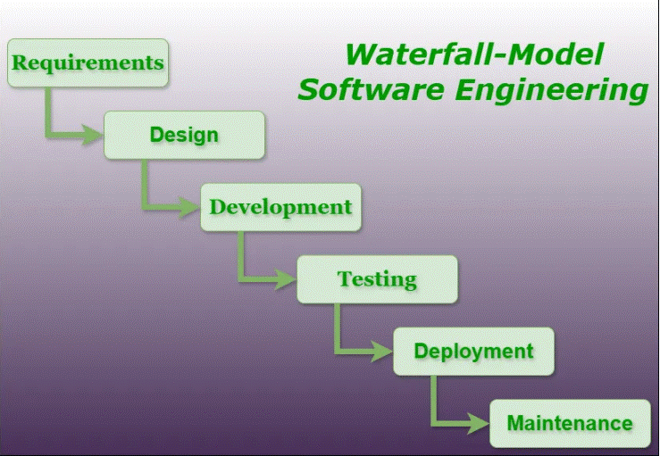

**Waterfall Model – Application**

Every software developed is different and requires a suitable SDLC approach to be followed based on the internal and external factors. Some situations where the use of Waterfall model is most appropriate are –

* Requirements are very well documented, clear and fixed.
* Product definition is stable.
* Technology is understood and is not dynamic.
* There are no ambiguous requirements.
* Ample resources with required expertise are available to support the product.
* The project is short

**Waterfall Model – Advantages:**

The advantages of waterfall development are that it allows for departmentalization and control. A schedule can be set with deadlines for each stage of development and a product can proceed through the development process model phases one by one.

Development moves from concept, through design, implementation, testing, installation, troubleshooting, and ends up at operation and maintenance. Each phase of development proceeds in strict order.

Some of the major advantages of the Waterfall Model are as follows –

* Simple and easy to understand and use
* Easy to manage due to the rigidity of the model. Each phase has specific deliverables and a review process.
* Phases are processed and completed one at a time.
* Works well for smaller projects where requirements are very well understood.
* Clearly defined stages.
* Well understood milestones.
* Easy to arrange tasks.
* Process and results are well documented.

**Waterfall Model – Disadvantages:**

The disadvantage of waterfall development is that it does not allow much reflection or revision. Once an application is in the testing stage, it is very difficult to go back and change something that was not well-documented or thought upon in the concept stage.

The major disadvantages of the Waterfall Model are as follows −

* No working software is produced until late during the life cycle.
* High amounts of risk and uncertainty.
* Not a good model for complex and object-oriented projects.
* Poor model for long and ongoing projects.
* Not suitable for the projects where requirements are at a moderate to high risk of changing. So, risk and uncertainty is high with this process model.
* It is difficult to measure progress within stages.
* Cannot accommodate changing requirements.
* Adjusting scope during the life cycle can end a project.
* Integration is done as a "big-bang. at the very end, which doesn't allow identifying any technological or business bottleneck or challenges early.

**PROJECT PLAN**

A project plan needs to be created to ensure the timely completion of the project. As part of project analysis, we break the project down to a number of stages and use a Gantt chart and PERT chart to describe specific tasks and status.

The work breakdown structure of our proposed system “Aqua Control” is shown below:-

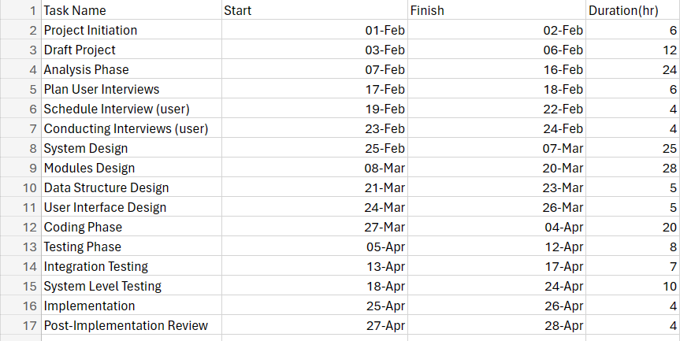

**GANTT CHART**

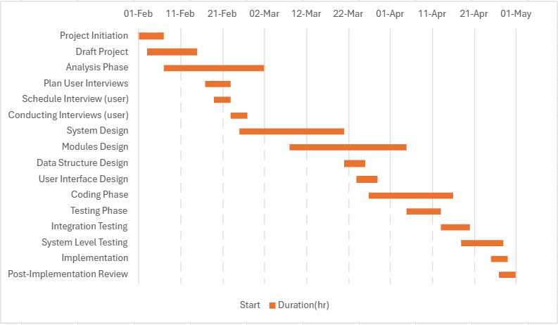

**FUTURE SCOPE**

With the advent of latest technology if we do not update our system then our business result in losses gradually with time. The technical system contains the tools of latest trend i.e. computers, printers, FAX, Internet etc the system with the technology are very fast, accurate, user friendly and reliable.

The proposed system helps them in many ways. It helps users to do billing very easily. Account maintenance also becomes easier. It can keep track of their supply,amount of water and account details. The software is provided with all the master entries to enter any type of water, or supplier, or customer to add or modify and delete.

Need of Aqua Control:

* To provide an optimal solution to the water supply and garbage collector supply.
* Maintaining the water supply.
* Water supply for specific period of time.
* To reduce unnecessary waste of water.
* To produce a Social Awareness About water saving Activity.
* Prototyping-Creating a mock –up of an application

**CONCLUSION**

This section discuses the result of work done in this project and also mentions the future scope improvement

The software will be developed by implementing the concept of modularity which in turn reduces the complexity involved in maintaining it. The administrator should have a sound technical knowledge about maintaining the software and further enhancements will be undertaken by the developer.

The application is portable which ensure its adaptability for use on different computer terminals with different operating system and standards.

The factors guarantee the software’s availability includes proper termination and correct input details. Also the resources used for the project development are Microsoft certified which speaks of its high quality standards.

Hence we may conclude that the application system being developed helps a great deal in modifying the computerized AQUA CONTROL.

**Goal achieved**: The System is able provide the interface to the user so that he can replicate his desired data.

**User friendly:** Though the most part of the system is supposed to act in the background, efforts have been made to make the foreground interaction with user as smooth as possible. Also the integration of the system with Water Supply Management project has been kept in mind throughout the development phase.

**BIBLOGRAPHY**

**BOOKS:**

1. Herbert Schildt, java2 complete reference, 5th edition, pregati

publication, April 2000

2. Abraham Silberschatz,Henry Korth,S.Sudarshan “Database

System Concept”, McGraw Hill 5th Edition 2006.

3. Rajeev Mall “Software Engineering”,TMH ,3rd Edition 1995.

4. Software engineering: a practitioners approach by Roger s

Pressman.

5. System analysis and design , Elias M. Ewad.

6. DBMS , Bipin C Desai

7. Introduction to DBMS ,Shailendra Sharma

8. Modern database management , Dr Kumar

9. Fundamentals of database systems , Ramez Elmsari

10. An intro to DBMS, Christhopher J Date

11. Database management systems ,Raghu Ramkrishnan

12. Principles of database systems , Jd Ullman

13. Foundation of databases ,Sergebabiteboul

14. Database systems , Connolly

15. Complete reference of java

16. Black book of java

WEBSITES:-

1. https://www.quora.com

2. https://www.geeksforgeeks.com

3. https://www.javaskyline.com

4. www.youtube.com

5. https://www.tutorialspoint.com/java

6. http://www.javatpoint.com/java-tutorial

7. https://docs.oracle.com/javase/tutorial

8. https://www.wampserver.com/en

9. https://www.tutorialspoint.com/mysql

10. http://www.jdbc-tutorial.com